**VISVESVARAYA TECHNOLOGICAL UNIVERSITY**

**“JnanaSangama”, Belgaum -590014, Karnataka.**



**LAB REPORT**

**on**

**Object Oriented Java Programming**

**(23CS3PCOOJ)**

***Submitted by***

**HRISHIKESH R PRASAD (1BM23CS367)**

***in partial fulfillment for the award of the degree of***

**BACHELOR OF ENGINEERING**

***in***

**COMPUTER SCIENCE AND ENGINEERING**



**B.M.S. COLLEGE OF ENGINEERING**

**(Autonomous Institution under VTU)**

**BENGALURU-560019**

**Sep-2024 to Jan-2025**

**B.M.S. College of Engineering,**

**Bull Temple Road, Bangalore 560019**

(Affiliated To Visvesvaraya Technological University, Belgaum)

**Department of Computer Science and Engineering**



**CERTIFICATE**

This is to certify that the Lab work entitled “Object Oriented Java Programming Lab (23CS3PCOOJ)carried out by **HRISHIKESH R PRASAD(1BM23CS367),** who is bonafide student of **B.M.S.College of Engineering.** It is in partial fulfillment for the award of **Bachelor of Engineering in Computer Science and Engineering** of the Visvesvaraya Technological University, Belgaum. The Lab report has been approved as it satisfies the academic requirements in respect of Object Oriented Java Programming Lab (23CS3PCOOJ) work prescribed for the said degree.

|  |  |
| --- | --- |
| Spoorthi D M  Assistant Professor  Department of CSE, BMSCE | Dr. Kavitha Sooda  Professor &HOD  Department of CSE, BMSCE |

**Index**

|  |  |  |  |
| --- | --- | --- | --- |
| **Sl.**  **No.** | **Date** | **Experiment Title** | **Page No.** |
| 1 | 26/09/2024 | Quadratic Equation Solution | 4 |
| 2 | 03/10/2024 | SGPA Calculation | 8 |
| 3 | 19/10/2024 | Library program: demonstration of toString() method | 15 |
| 4 | 24/10/2024 | Abstract Class demonstration program | 21 |
| 5 | 07/11/2024 | Inheritance demonstration program | 28 |
| 6 | 14/11/2024 | Packages in java demonstration | 38 |
| 7 | 21/11/2024 | Exception handling | 47 |
| 8 | 28/11/2024 | Multithreaded Programming | 53 |
| 9 | 19/12/2024 | Open ended exercise-1: Event Handling | 56 |
| 10 | 19/12/2024 | Open ended exercise-2: IPC and Deadlock | 61 |

Github Link:

<https://github.com/Hrishikesh-R-Prasad/OOPwithJava>

Q1. Develop a Java program that prints all real solutions to the quadratic equation ax2+bx+c = 0. Read in a, b, c and use the quadratic formula. If the discriminate b2-4ac is negative, display a message stating that there are no real solutions.

import java.util.Scanner;

public class QuadraticEquationSolver { public static void main(String[] args) { Scanner scanner = new Scanner(System.in);

// Read coefficients a, b, c from the user  
 System.out.print("Enter coefficient a: ");  
 double a = scanner.nextDouble();  
 System.out.print("Enter coefficient b: ");  
 double b = scanner.nextDouble();  
 System.out.print("Enter coefficient c: ");  
 double c = scanner.nextDouble();  
  
 // Calculate the discriminant: b^2 - 4ac  
 double discriminant = b * b - 4 * a * c;  
  
 // Check the nature of the discriminant  
 if (discriminant > 0) {  
 // Two real and distinct roots  
 double root1 = (-b + Math.sqrt(discriminant)) / (2 * a);  
 double root2 = (-b - Math.sqrt(discriminant)) / (2 * a);  
 System.out.println("The equation has two real and distinct roots:");  
 System.out.println("Root 1: " + root1);  
 System.out.println("Root 2: " + root2);  
 } else if (discriminant == 0) {  
 // One real root (repeated)  
 double root = -b / (2 * a);  
 System.out.println("The equation has one real and repeated root:");  
 System.out.println("Root: " + root);  
 } else {  
 // No real solutions  
 System.out.println("The equation has no real solutions.");  
 }  
  
 scanner.close();  
}

}

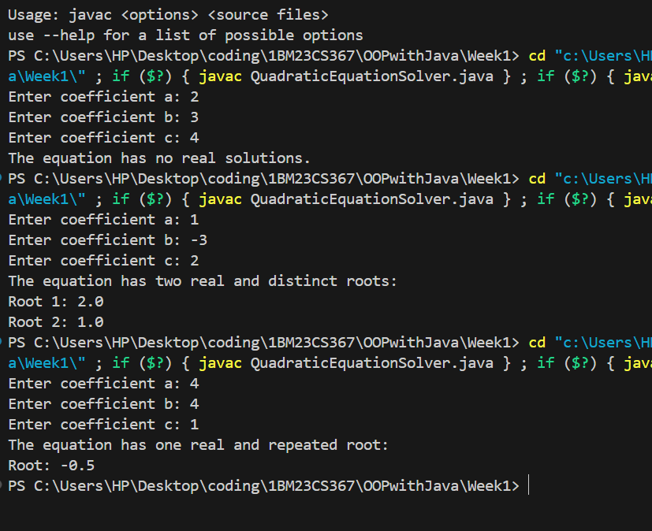

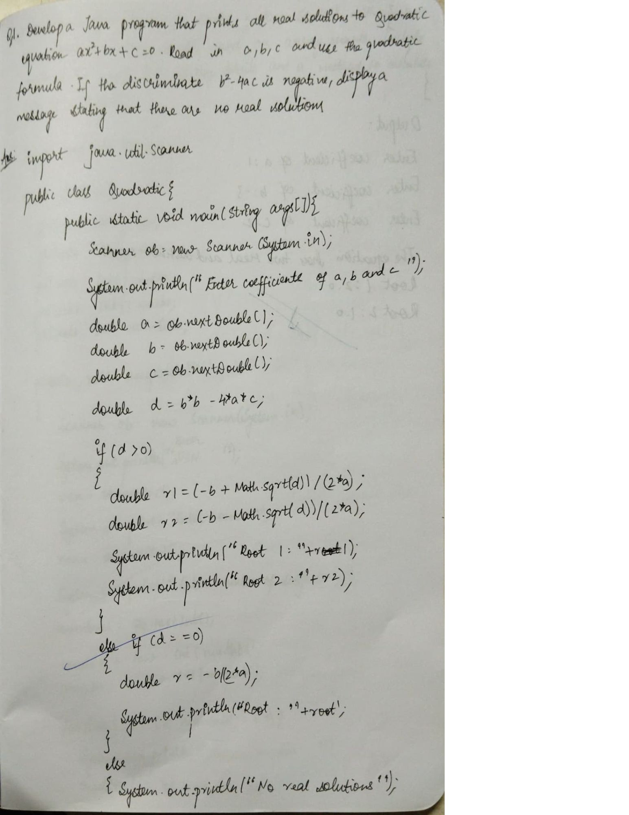

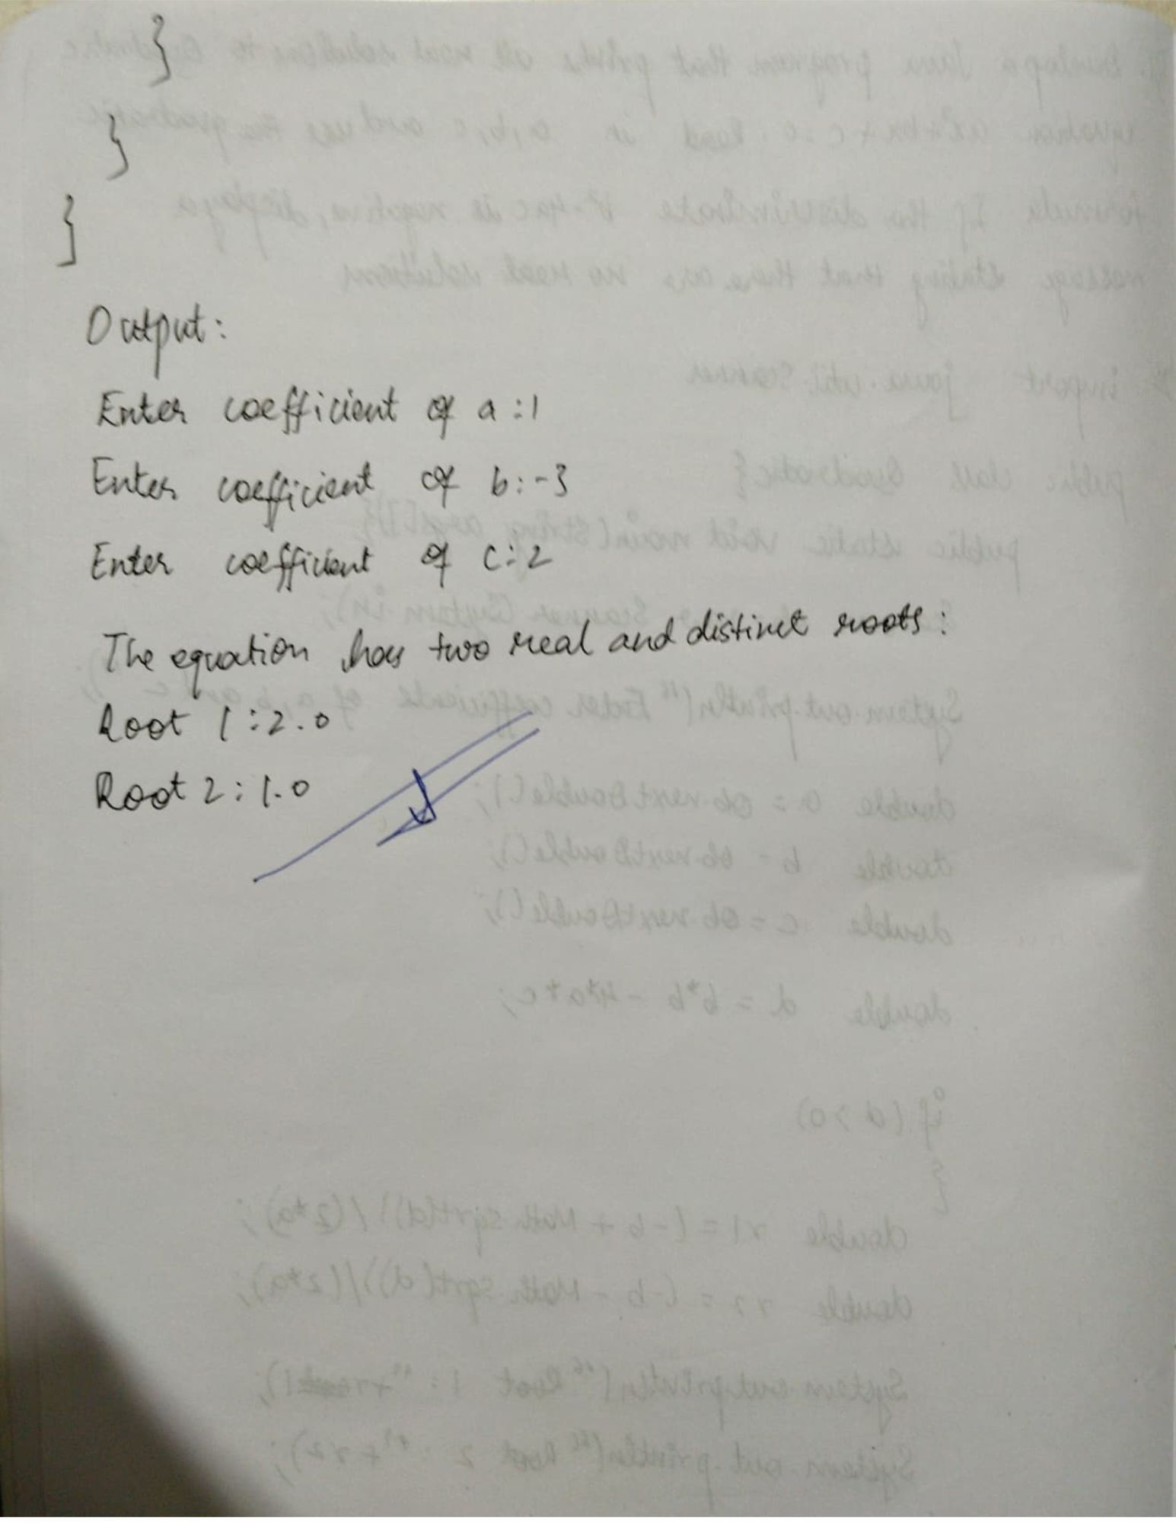

Q2 Develop a Java program to create a class Student with members usn, name, an array credits and an array marks. Include methods to accept and display details and a method to calculate SGPA of a student.

import java.util.Scanner;

class Student {

private String usn;

private String name;

private int[] credits;

private int[] marks;

private int numSubjects;

public void acceptDetails() {

Scanner scanner = new Scanner(System.in);

System.out.print("Enter USN: ");

usn = scanner.nextLine();

System.out.print("Enter Name: ");

name = scanner.nextLine();

System.out.print("Enter the number of subjects: ");

numSubjects = scanner.nextInt();

credits = new int[numSubjects];

marks = new int[numSubjects];

for (int i = 0; i < numSubjects; i++) {

System.out.print("Enter credits for subject " + (i + 1) + ": ");

credits[i] = scanner.nextInt();

System.out.print("Enter marks for subject " + (i + 1) + ": ");

marks[i] = scanner.nextInt();

}

}

public void displayDetails() {

System.out.println("\nStudent Details:");

System.out.println("USN: " + usn);

System.out.println("Name: " + name);

System.out.println("Number of Subjects: " + numSubjects);

for (int i = 0; i < numSubjects; i++) {

System.out.println("Subject " + (i + 1) + ": Credits = " + credits[i] + ", Marks = " + marks[i]);

}

}

public double calculateSGPA() {

int totalCredits = 0;

int totalGradePoints = 0;

for (int i = 0; i < numSubjects; i++) {

int gradePoint = getGradePoint(marks[i]);

totalGradePoints += gradePoint * credits[i];

totalCredits += credits[i];

}

if (totalCredits > 0) {

return (double) totalGradePoints / totalCredits;

} else {

return 0.0;

}

}

private int getGradePoint(int marks) {

if (marks >= 90) return 10;

else if (marks >= 80) return 9;

else if (marks >= 70) return 8;

else if (marks >= 60) return 7;

else if (marks >= 50) return 6;

else if (marks >= 40) return 5;

else return 0;

}

}

public class Main {

public static void main(String[] args) {

Student student = new Student();

student.acceptDetails();

student.displayDetails();

double sgpa = student.calculateSGPA();

System.out.println("\nSGPA: " + sgpa);

}

}

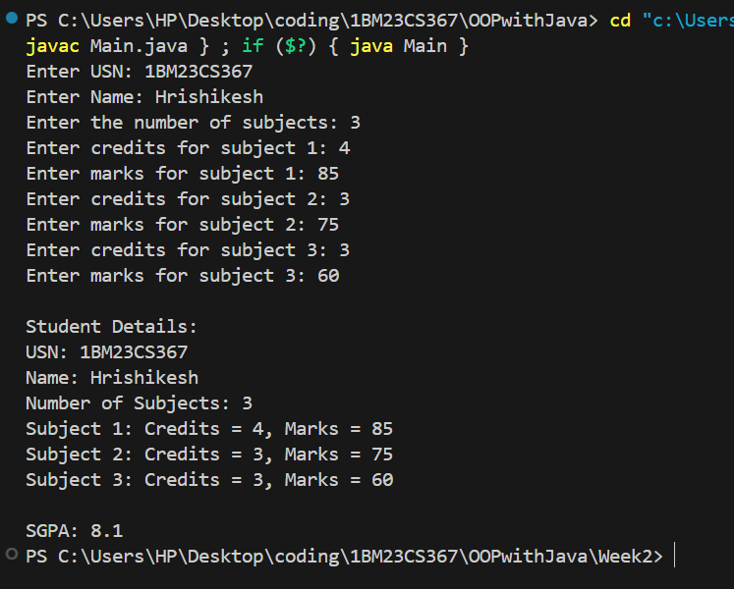

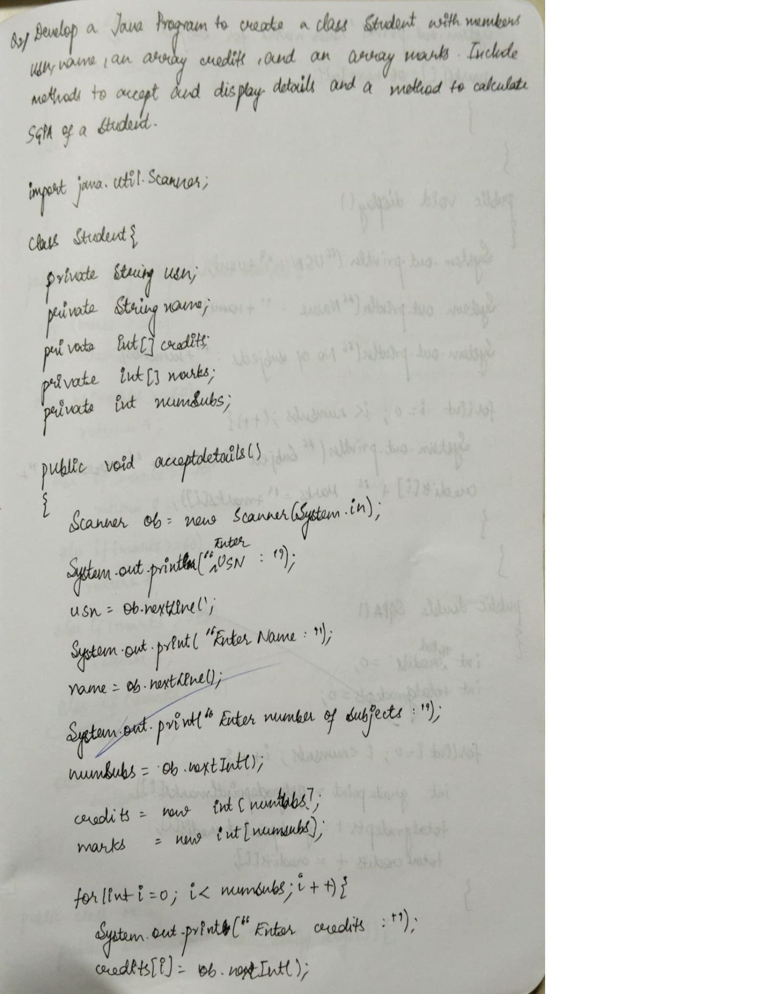

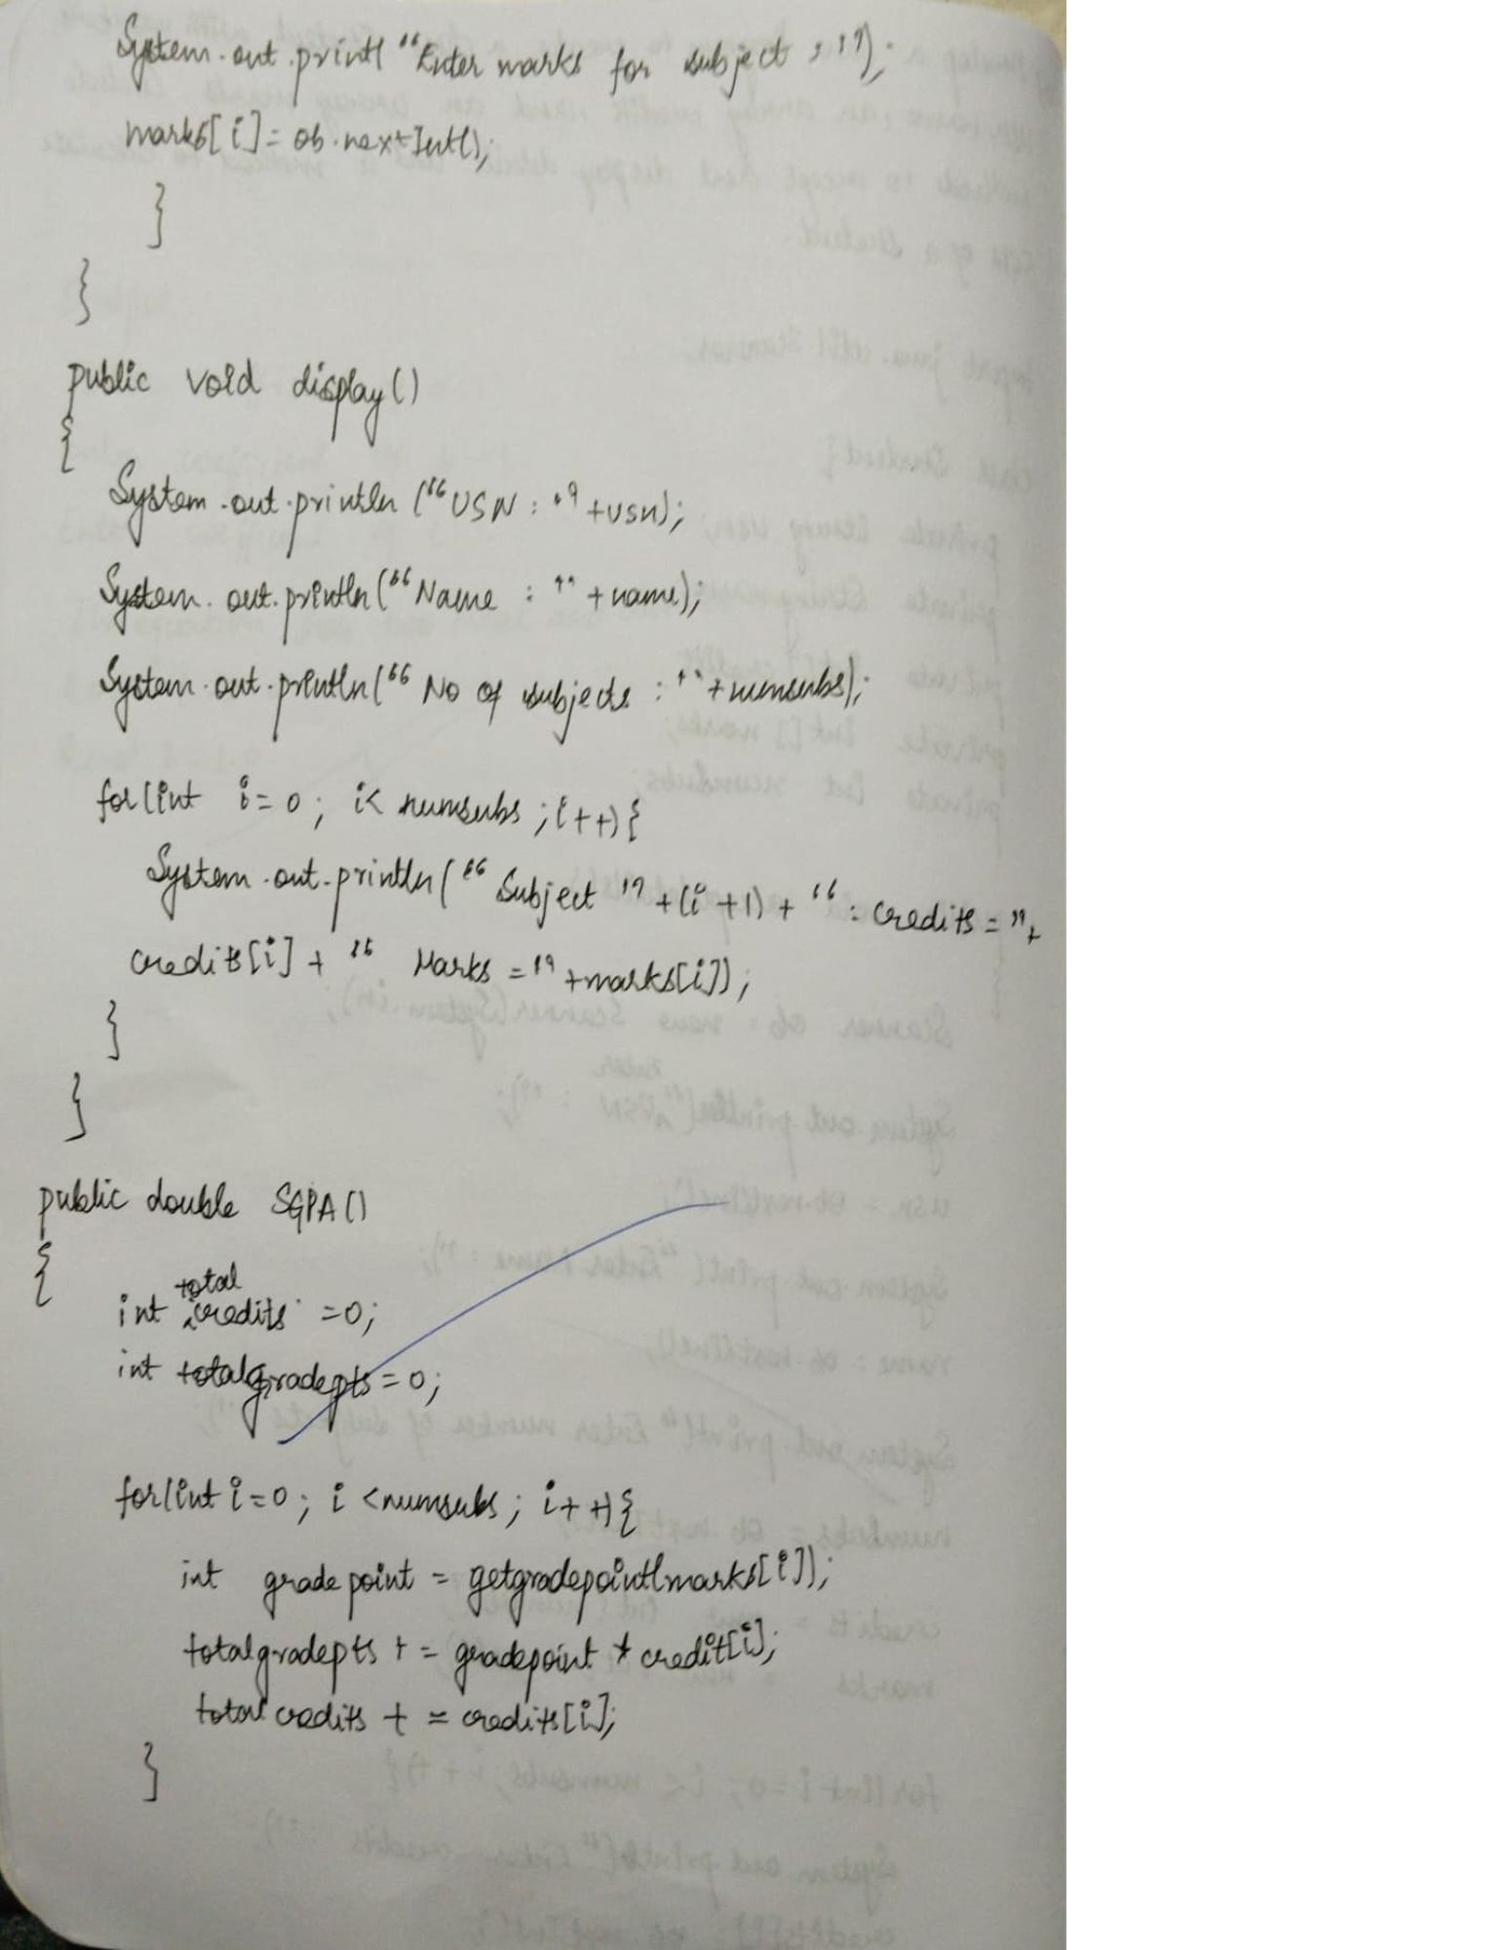

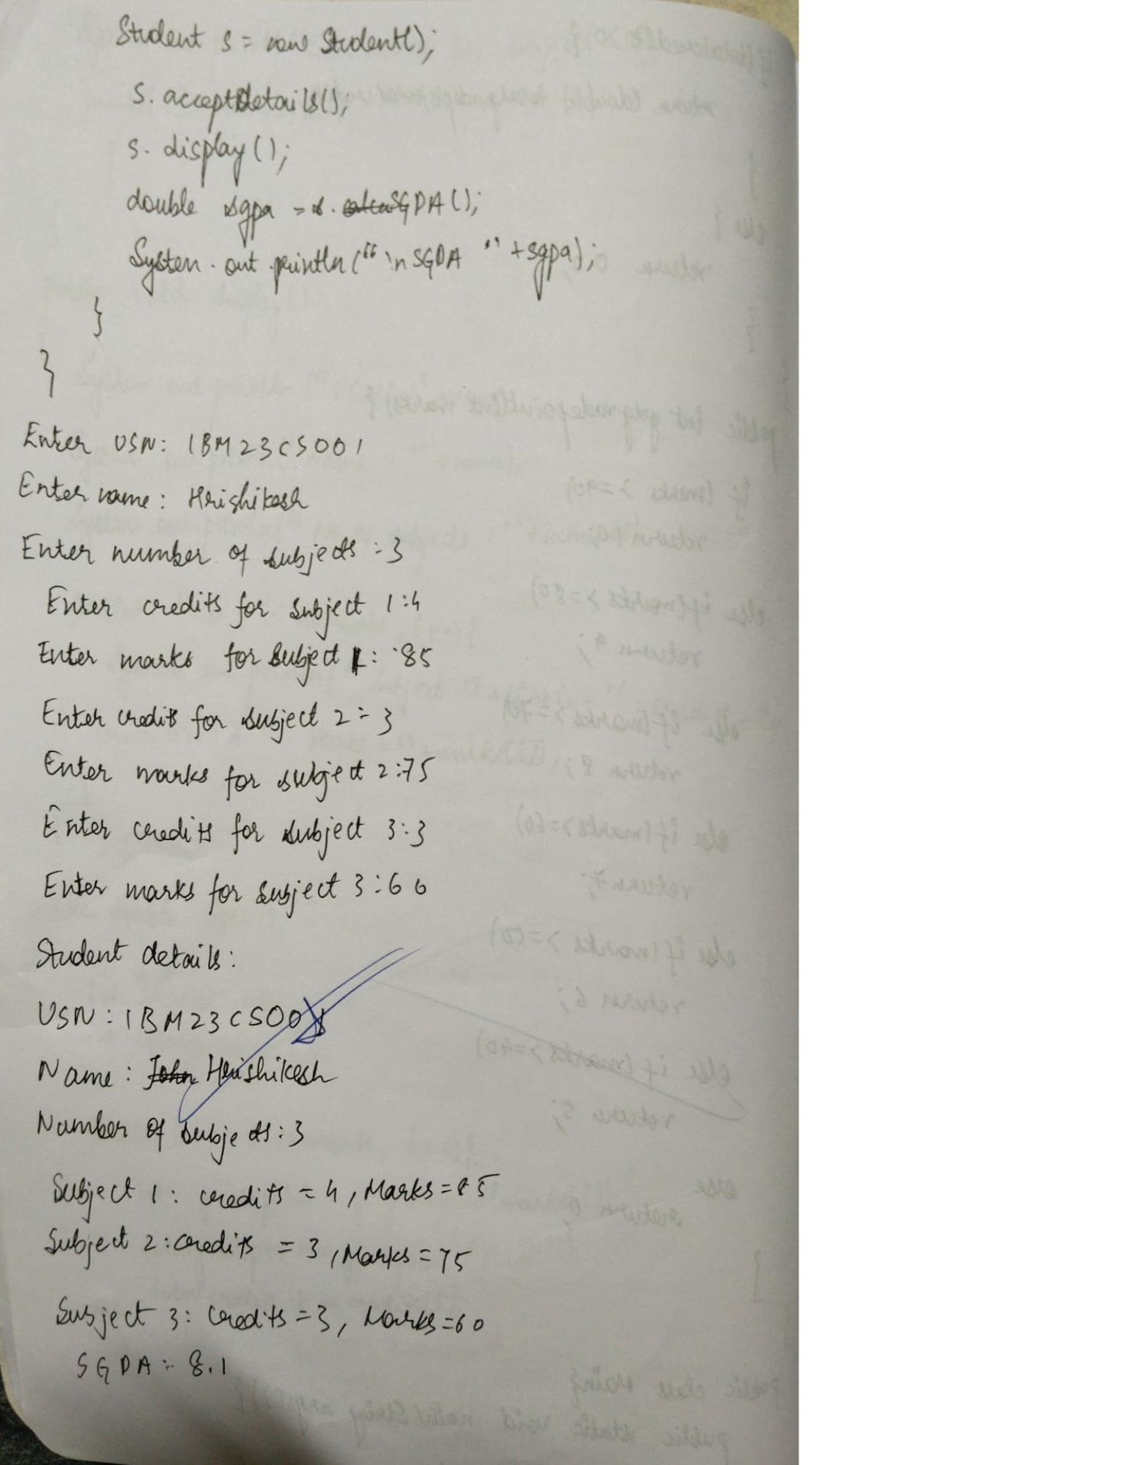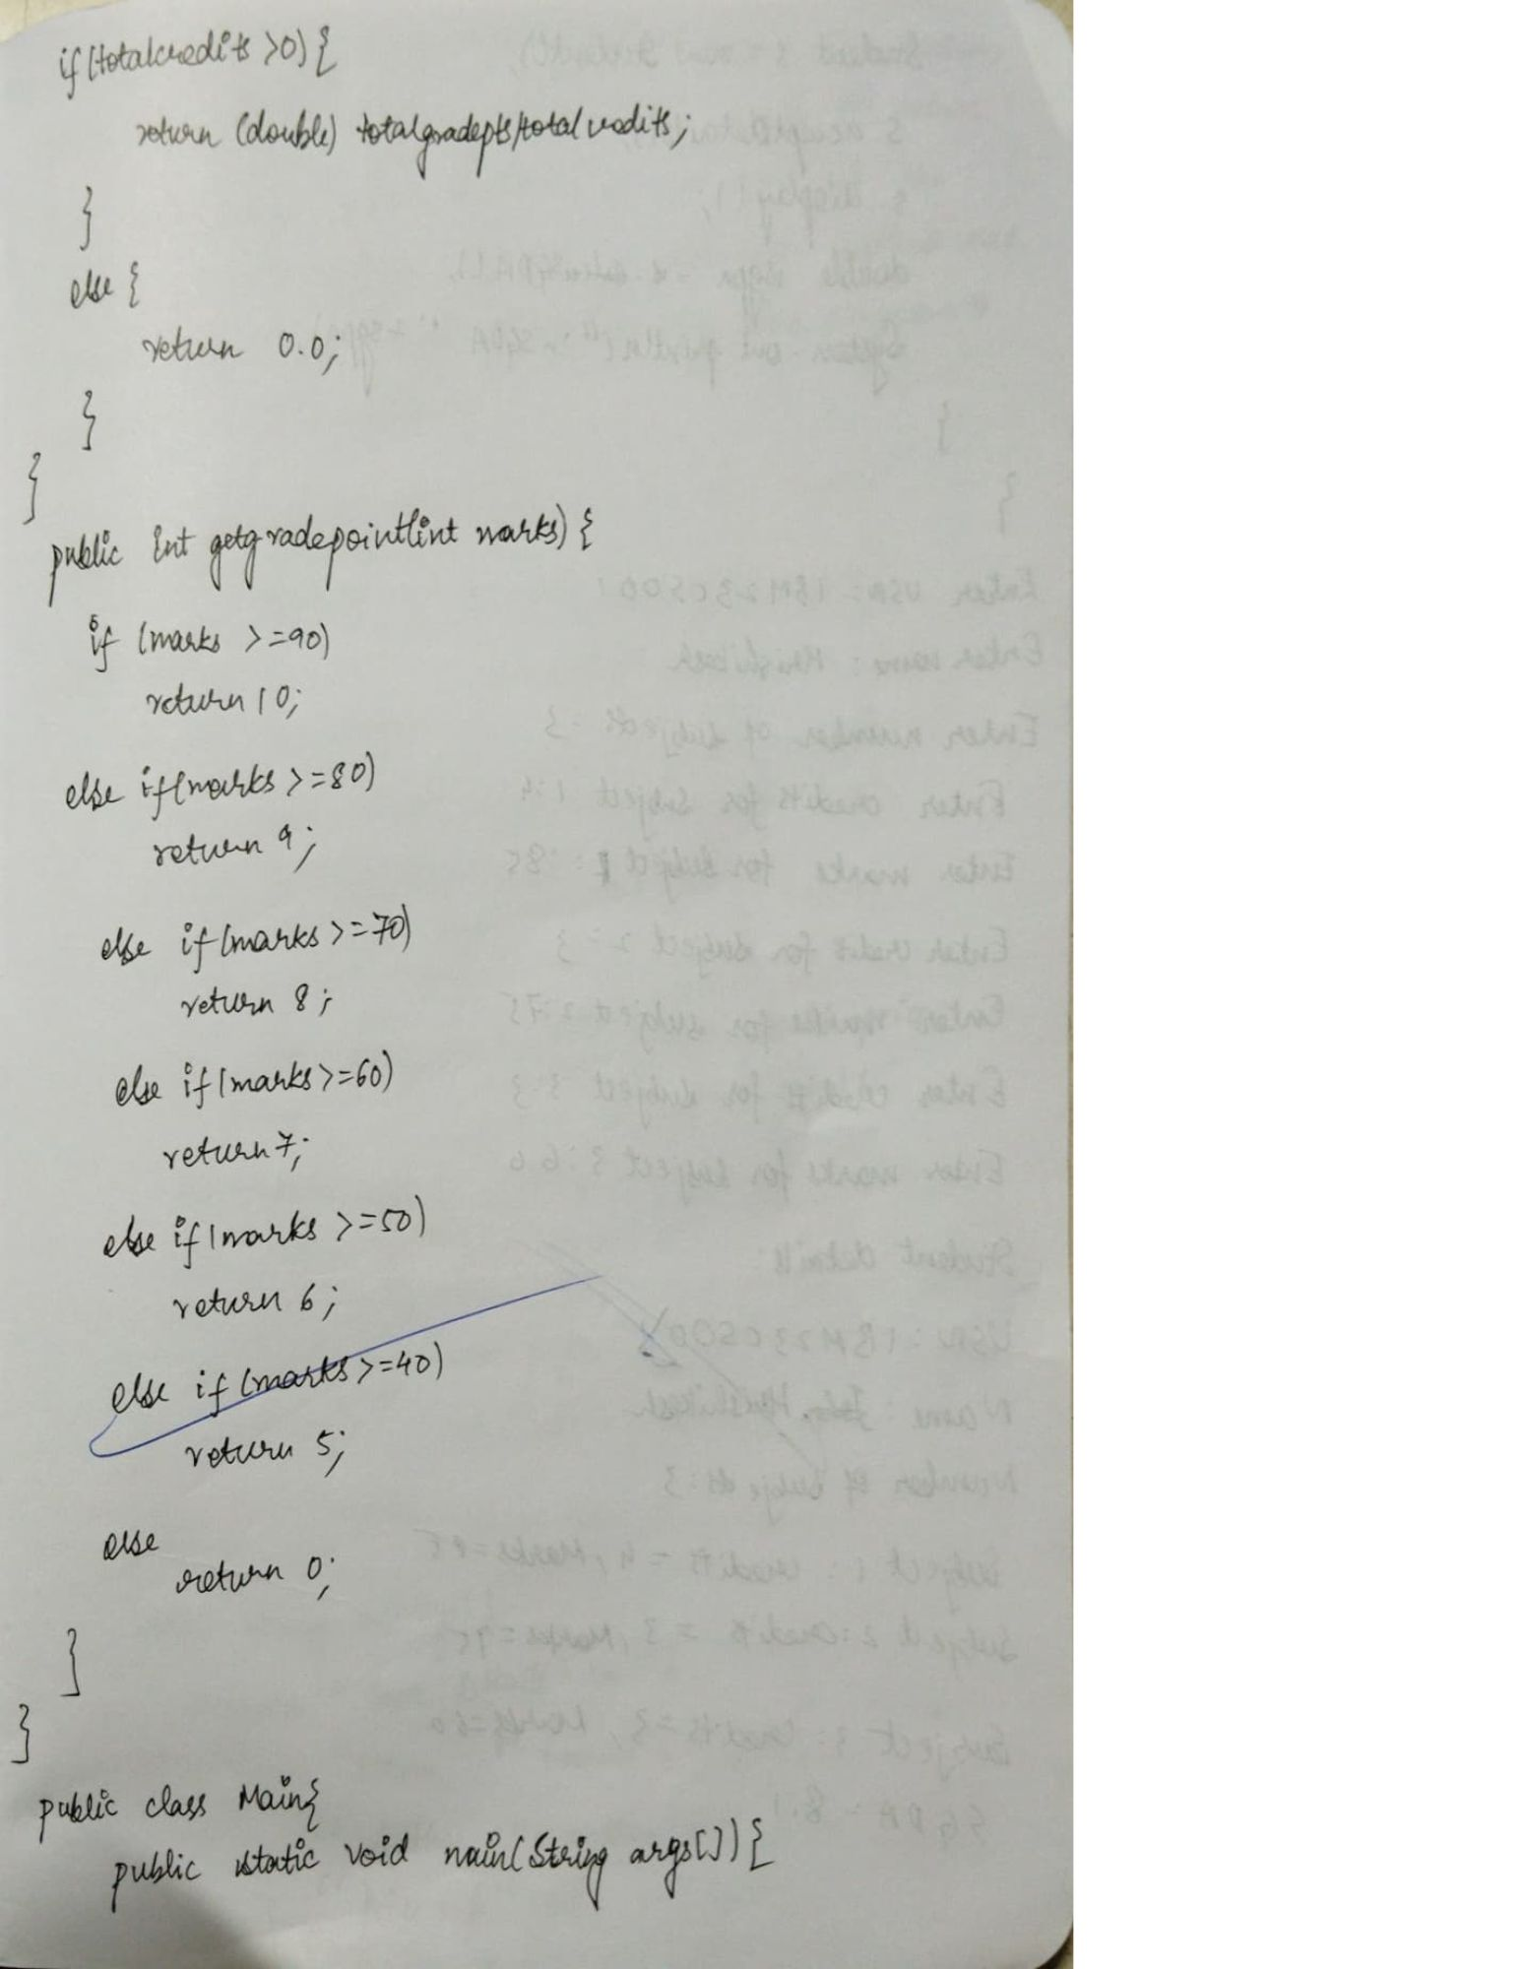

Q3 Create a class Book which contains four members: name,

author, price, num_pages. Include a constructor to set the

values for the members. Include methods to set and get

the details of the objects. Include a toString( ) method that

could display the complete details of the book. Develop a

Java program to create n book objects.

import java.util.Scanner;

class Book { private String name; private String author; private double price; private int num_pages;

public Book(String name, String author, double price, int num_pages) {  
 this.name = name;  
 this.author = author;  
 this.price = price;  
 this.num_pages = num_pages;  
}  
  
  
public void setDetails(String name, String author, double price, int num_pages) {  
 this.name = name;  
 this.author = author;  
 this.price = price;  
 this.num_pages = num_pages;  
}  
  
public String getName() {  
 return name;  
}  
  
public String getAuthor() {  
 return author;  
}  
  
public double getPrice() {  
 return price;  
}  
  
public int getNumPages() {  
 return num_pages;  
}  
  
  
public String toString() {  
 return "Book Details:\n" +  
 "Name: " + name + "\n" +  
 "Author: " + author + "\n" +  
 "Price: $" + price + "\n" +  
 "Number of Pages: " + num_pages;  
}

}

public class Main { public static void main(String[] args) { Scanner scanner = new Scanner(System.in);

System.out.print("Enter the number of books: ");  
 int n = scanner.nextInt();  
 scanner.nextLine();  
  
  
 Book[] books = new Book[n];  
  
  
 for (int i = 0; i < n; i++) {  
 System.out.println("\nEnter details for Book " + (i + 1) + ":");  
   
 System.out.print("Enter Name: ");  
 String name = scanner.nextLine();  
   
 System.out.print("Enter Author: ");  
 String author = scanner.nextLine();  
   
 System.out.print("Enter Price: ");  
 double price = scanner.nextDouble();  
   
 System.out.print("Enter Number of Pages: ");  
 int num_pages = scanner.nextInt();  
 scanner.nextLine();  
  
  
 books[i] = new Book(name, author, price, num_pages);  
 }  
  
  
 System.out.println("\n--- Book List ---");  
 for (int i = 0; i < n; i++) {  
 System.out.println("\nBook " + (i + 1) + ":");  
 System.out.println(books[i].toString());  
 }  
  
 scanner.close();  
}

}

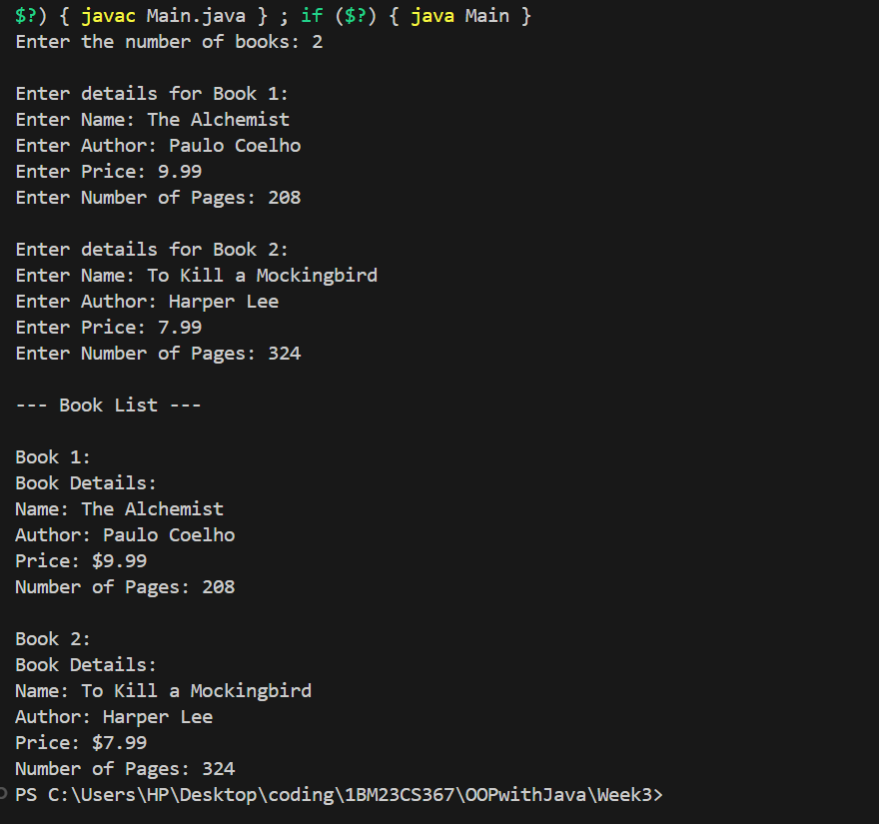

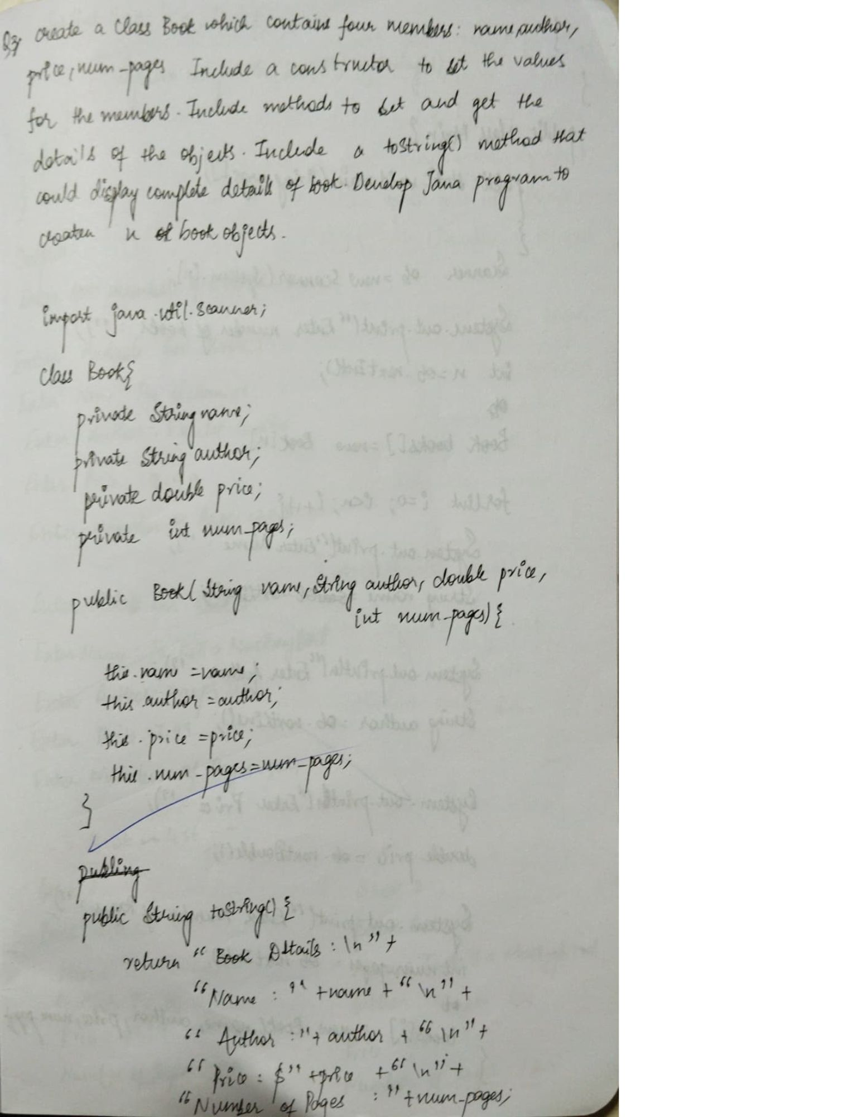

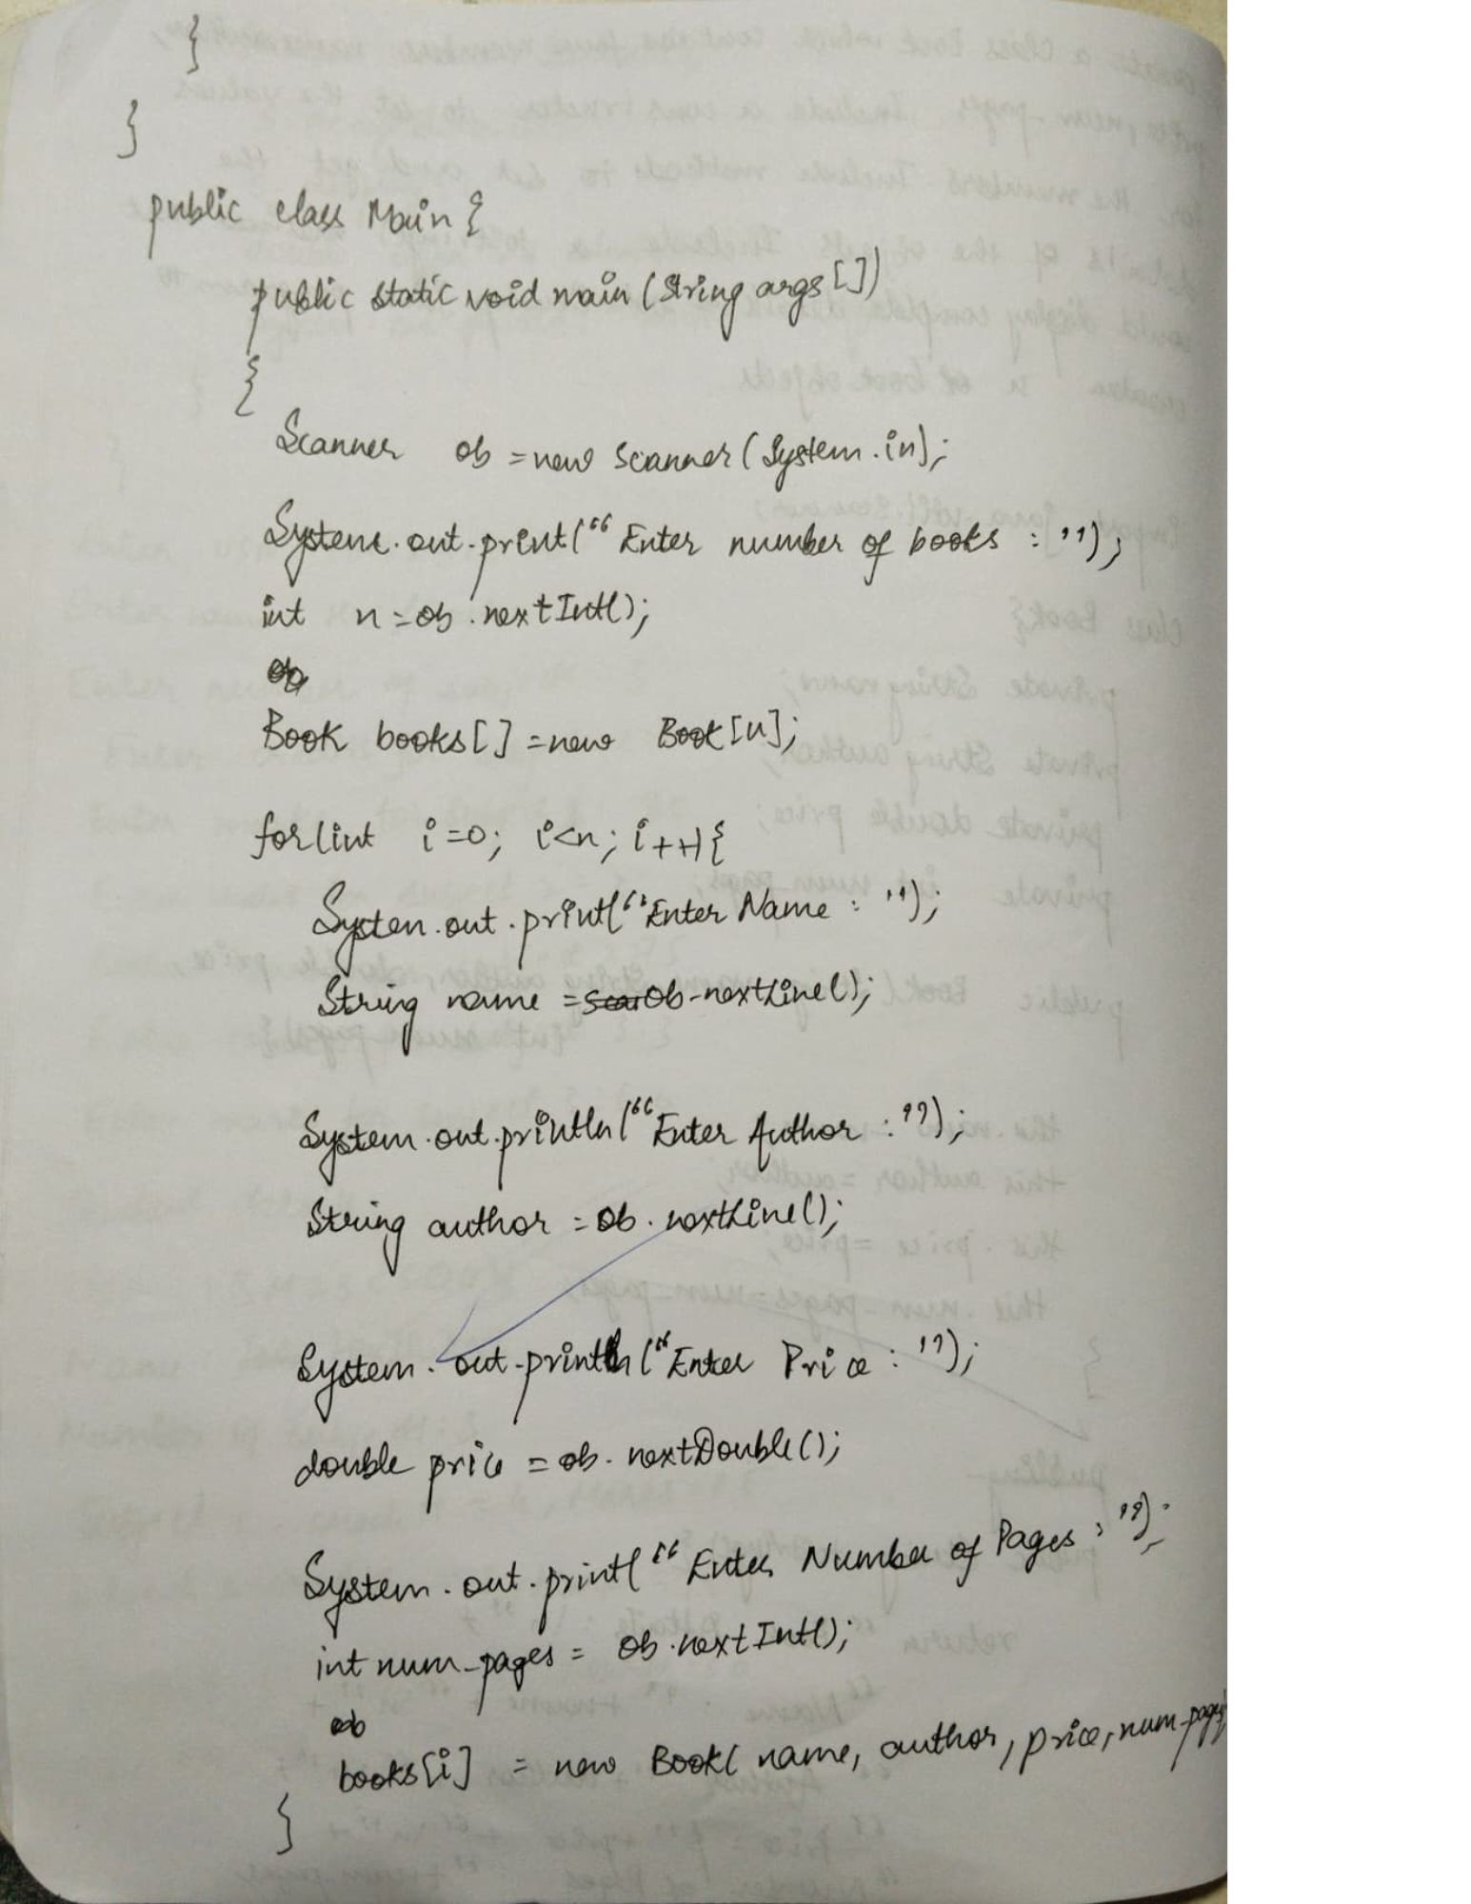

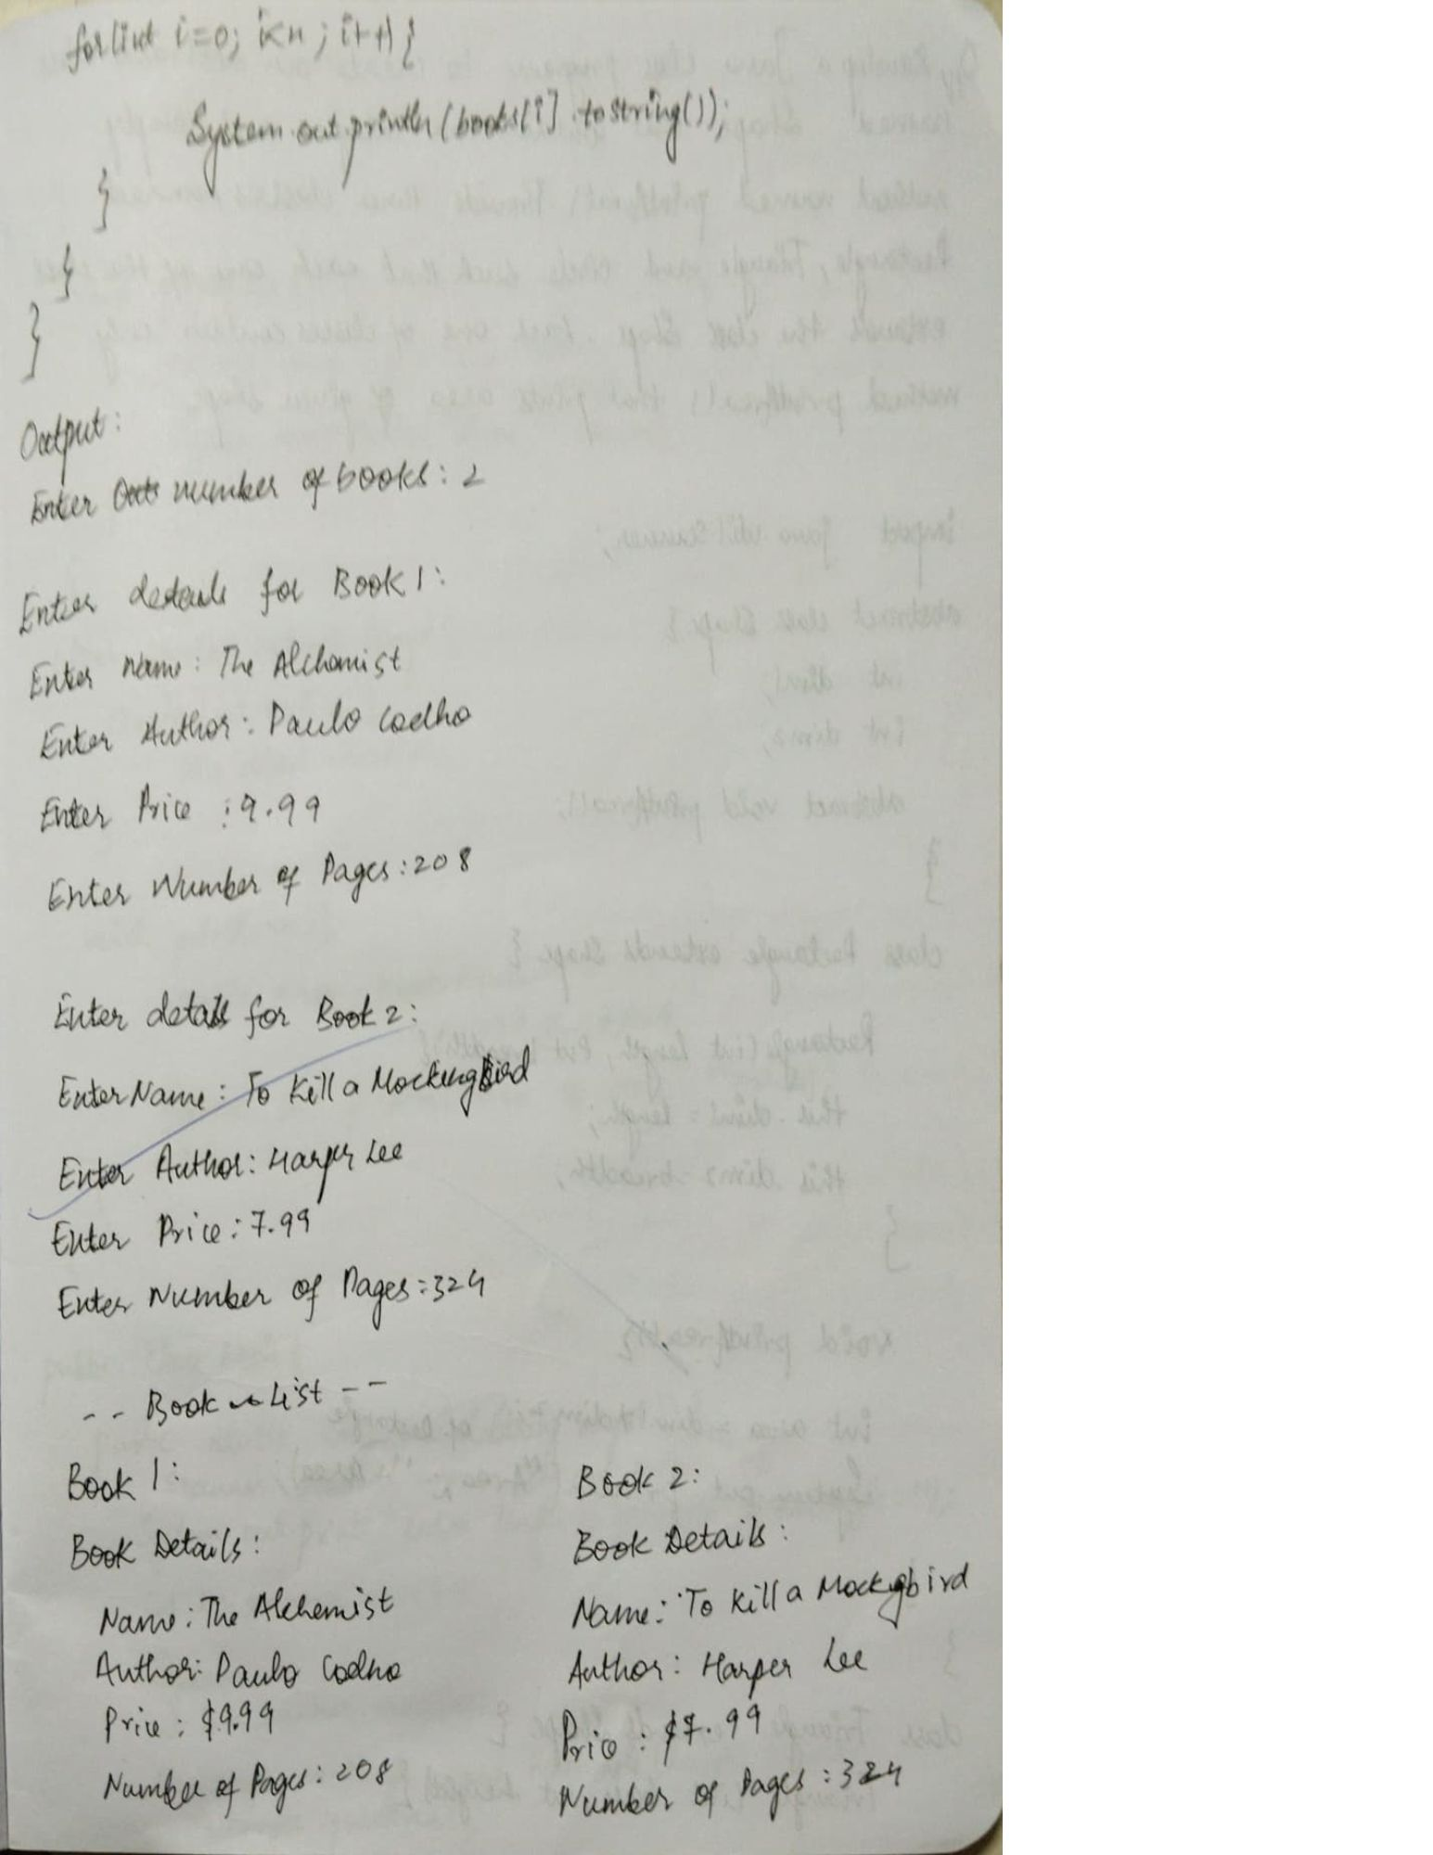

Q4 Develop a Java program to create an abstract class named

Shape that contains two integers and an empty method

named printArea(). Provide three classes named

Rectangle, Triangle and Circle such that each one of the

classes extends the class Shape. Each one of the classes

contain only the method printArea() that prints the area of

the given shape.

import java.util.Scanner;

abstract class Shape { int dimension1; int dimension2;

abstract void printArea();

}

class Rectangle extends Shape {

Rectangle(int length, int breadth) {  
 this.dimension1 = length;  
 this.dimension2 = breadth;  
}  
  
  
  
void printArea() {  
 int area = dimension1 * dimension2;  
 System.out.println("Area of Rectangle: " + area);  
}

}

class Triangle extends Shape {

Triangle(int base, int height) {  
 this.dimension1 = base;  
 this.dimension2 = height;  
}  
  
void printArea() {  
 double area = 0.5 * dimension1 * dimension2;  
 System.out.println("Area of Triangle: " + area);  
}

}

class Circle extends Shape {

Circle(int radius) {  
 this.dimension1 = radius;  
}  
  
  
void printArea() {  
 double area = Math.PI * dimension1 * dimension1;  
 System.out.println("Area of Circle: " + area);  
}

}

public class Main { public static void main(String[] args) { Scanner scanner = new Scanner(System.in);

System.out.print("Enter the length of the Rectangle: ");  
 int length = scanner.nextInt();  
 System.out.print("Enter the breadth of the Rectangle: ");  
 int breadth = scanner.nextInt();  
 Rectangle rectangle = new Rectangle(length, breadth);  
 rectangle.printArea();  
  
  
 System.out.print("\nEnter the base of the Triangle: ");  
 int base = scanner.nextInt();  
 System.out.print("Enter the height of the Triangle: ");  
 int height = scanner.nextInt();  
 Triangle triangle = new Triangle(base, height);  
 triangle.printArea();  
  
  
 System.out.print("\nEnter the radius of the Circle: ");  
 int radius = scanner.nextInt();  
 Circle circle = new Circle(radius);  
 circle.printArea();  
  
 scanner.close();  
}

}

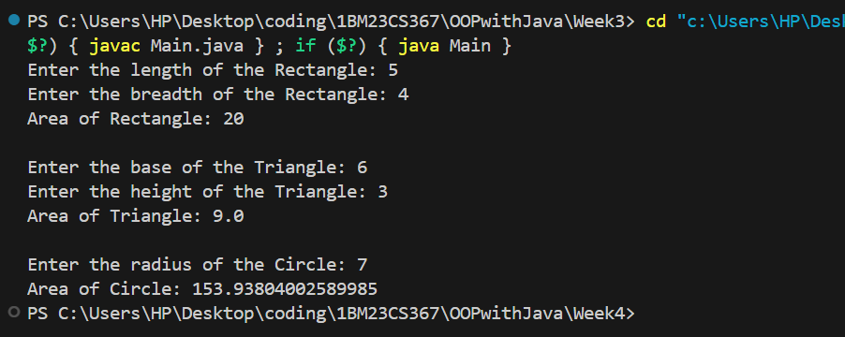

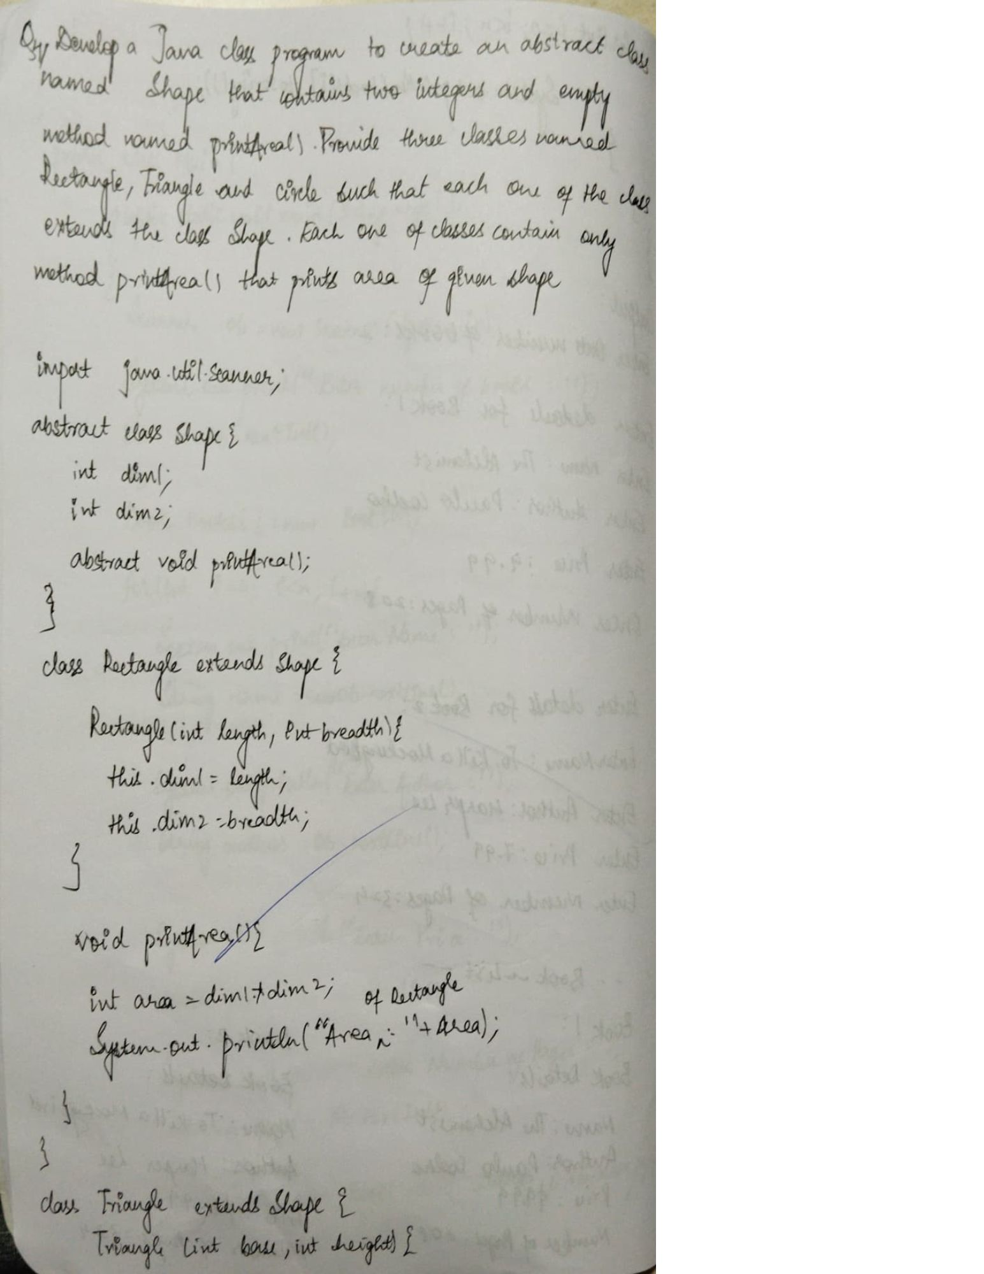

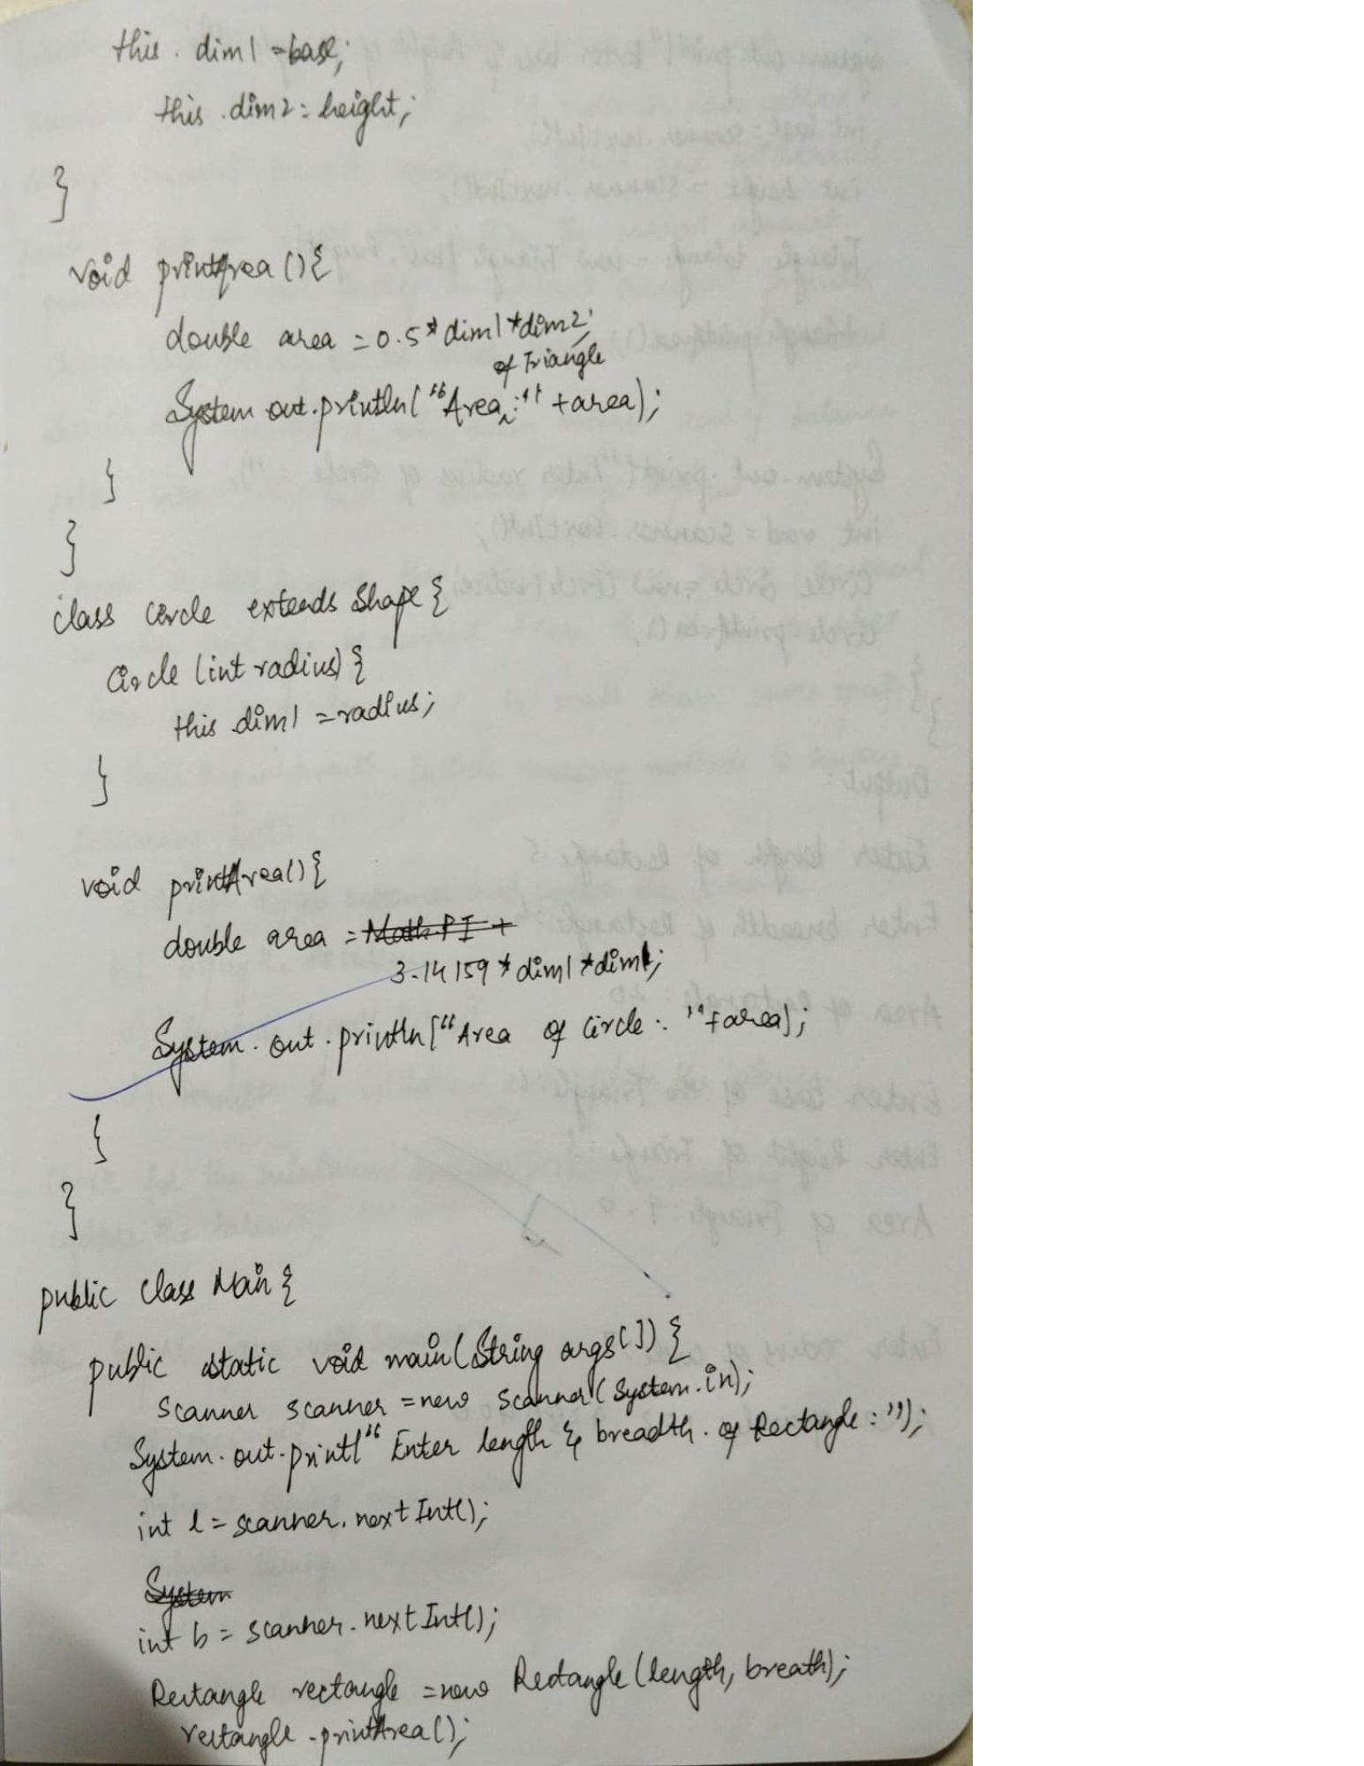

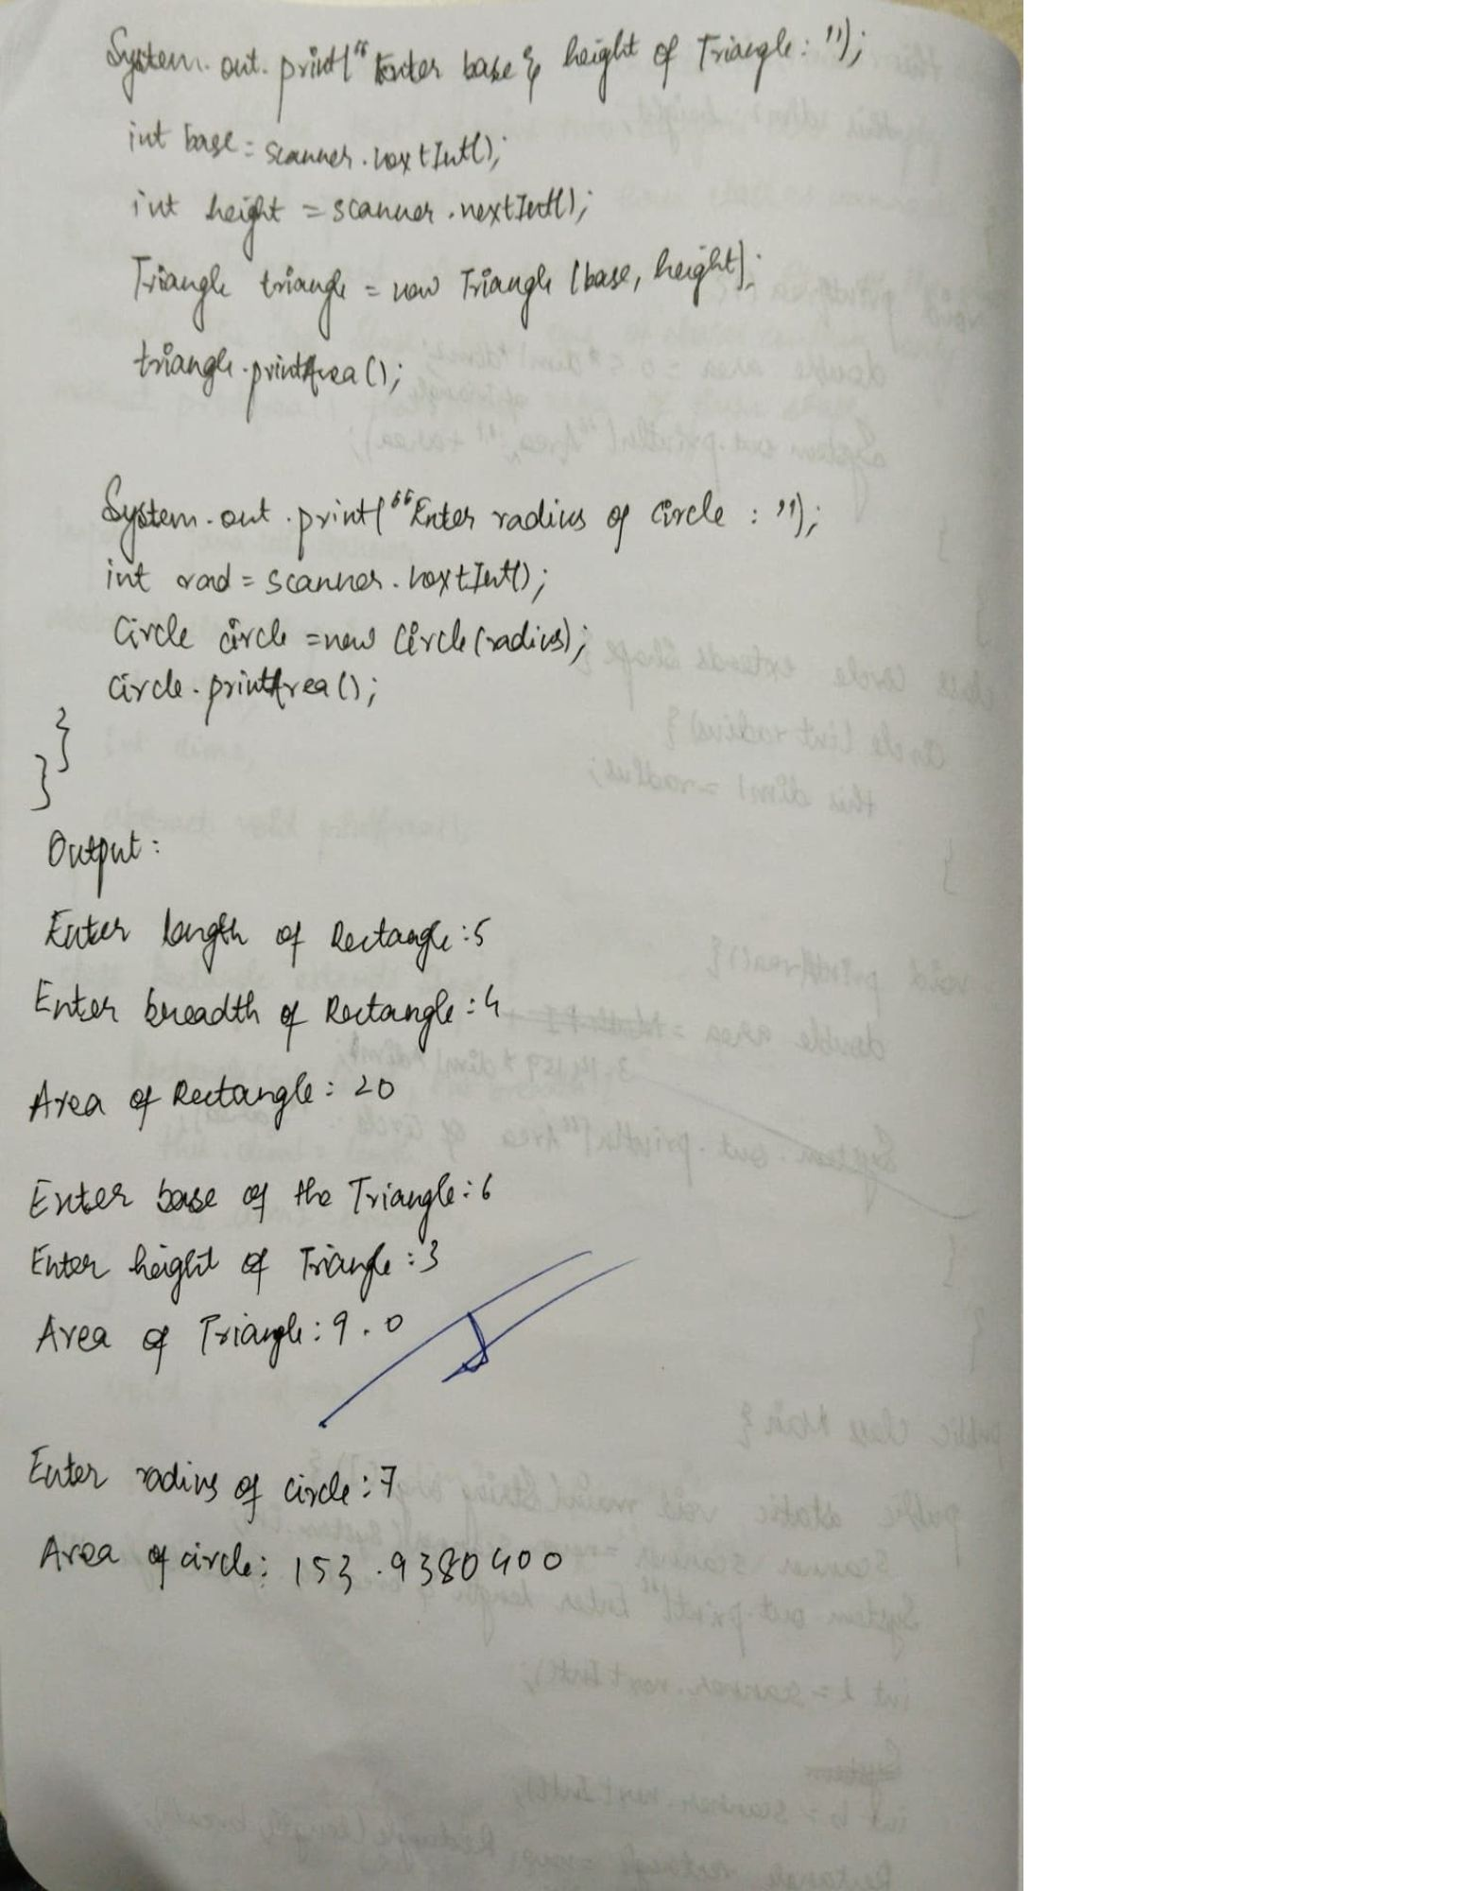

Q5.Develop a Java program to create a class Bank that

maintains two kinds of account for its customers, one

called savings account and the other current account. The

savings account provides compound interest and

withdrawal facilities but no cheque book facility. The

current account provides cheque book facility but no

interest. Current account holders should also maintain a

minimum balance and if the balance falls below this level,

a service charge is imposed.

Create a class Account that stores customer name,

account number and type of account. From this derive the

classes Cur-acct and Sav-acct to make them more specific

to their requirements. Include the necessary methods in

order to achieve the following tasks:

a) Accept deposit from customer and update

the balance.

b) Display the balance.

c) Compute and deposit interest

d) Permit withdrawal and update the balance

Check for the minimum balance, impose penalty if

necessary and update the balance.

import java.util.Scanner;

class Account {

private String customerName;

private String accountNumber;

private String accountType;

private double balance;

public Account(String customerName, String accountNumber, String accountType) {

this.customerName = customerName;

this.accountNumber = accountNumber;

this.accountType = accountType;

this.balance = 0.0;

}

public String getCustomerName() {

return customerName;

}

public String getAccountNumber() {

return accountNumber;

}

public String getAccountType() {

return accountType;

}

public double getBalance() {

return balance;

}

public void deposit(double amount) {

if (amount > 0) {

balance += amount;

System.out.println("Deposited: $" + amount);

} else {

System.out.println("Invalid deposit amount.");

}

}

public void displayBalance() {

System.out.println("Balance: $" + balance);

}

public void updateBalance(double amount) {

balance = amount;

}

}

class SavAcct extends Account {

private double interestRate;

public SavAcct(String customerName, String accountNumber, double interestRate) {

super(customerName, accountNumber, "Savings");

this.interestRate = interestRate;

}

public void computeInterest(int years) {

double balance = getBalance();

double interest = balance * Math.pow((1 + interestRate / 100), years) - balance;

deposit(interest);

System.out.println("Interest of $" + interest + " added to your account.");

}

public void withdraw(double amount) {

double balance = getBalance();

if (amount > 0 && amount <= balance) {

updateBalance(balance - amount);

System.out.println("Withdrawn: $" + amount);

} else {

System.out.println("Insufficient balance or invalid amount.");

}

}

}

class CurAcct extends Account {

private double minBalance;

private double penalty;

public CurAcct(String customerName, String accountNumber, double minBalance, double penalty) {

super(customerName, accountNumber, "Current");

this.minBalance = minBalance;

this.penalty = penalty;

}

public void withdraw(double amount) {

double balance = getBalance();

if (amount > 0 && amount <= balance) {

updateBalance(balance - amount);

System.out.println("Withdrawn: $" + amount);

if (getBalance() < minBalance) {

updateBalance(getBalance() - penalty);

System.out.println("Balance below minimum. Penalty of $" + penalty + " imposed.");

}

} else {

System.out.println("Insufficient balance or invalid amount.");

}

}

}

public class Main {

public static void main(String[] args) {

Scanner scanner = new Scanner(System.in);

System.out.print("Enter customer name for Savings Account: ");

String savName = scanner.nextLine();

System.out.print("Enter account number for Savings Account: ");

String savAccNum = scanner.nextLine();

SavAcct savAccount = new SavAcct(savName, savAccNum, 4.0);

savAccount.deposit(1000);

savAccount.computeInterest(2);

savAccount.displayBalance();

savAccount.withdraw(500);

savAccount.displayBalance();

System.out.println("\n--------------------\n");

System.out.print("Enter customer name for Current Account: ");

String curName = scanner.nextLine();

System.out.print("Enter account number for Current Account: ");

String curAccNum = scanner.nextLine();

CurAcct curAccount = new CurAcct(curName, curAccNum, 500, 50);

curAccount.deposit(1500);

curAccount.displayBalance();

curAccount.withdraw(1200);

curAccount.displayBalance();

curAccount.withdraw(500);

curAccount.displayBalance();

scanner.close();

}

}

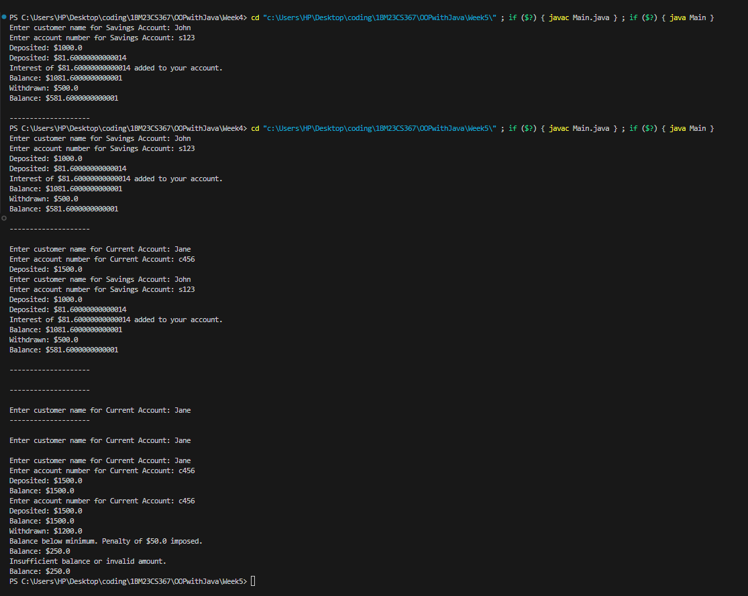

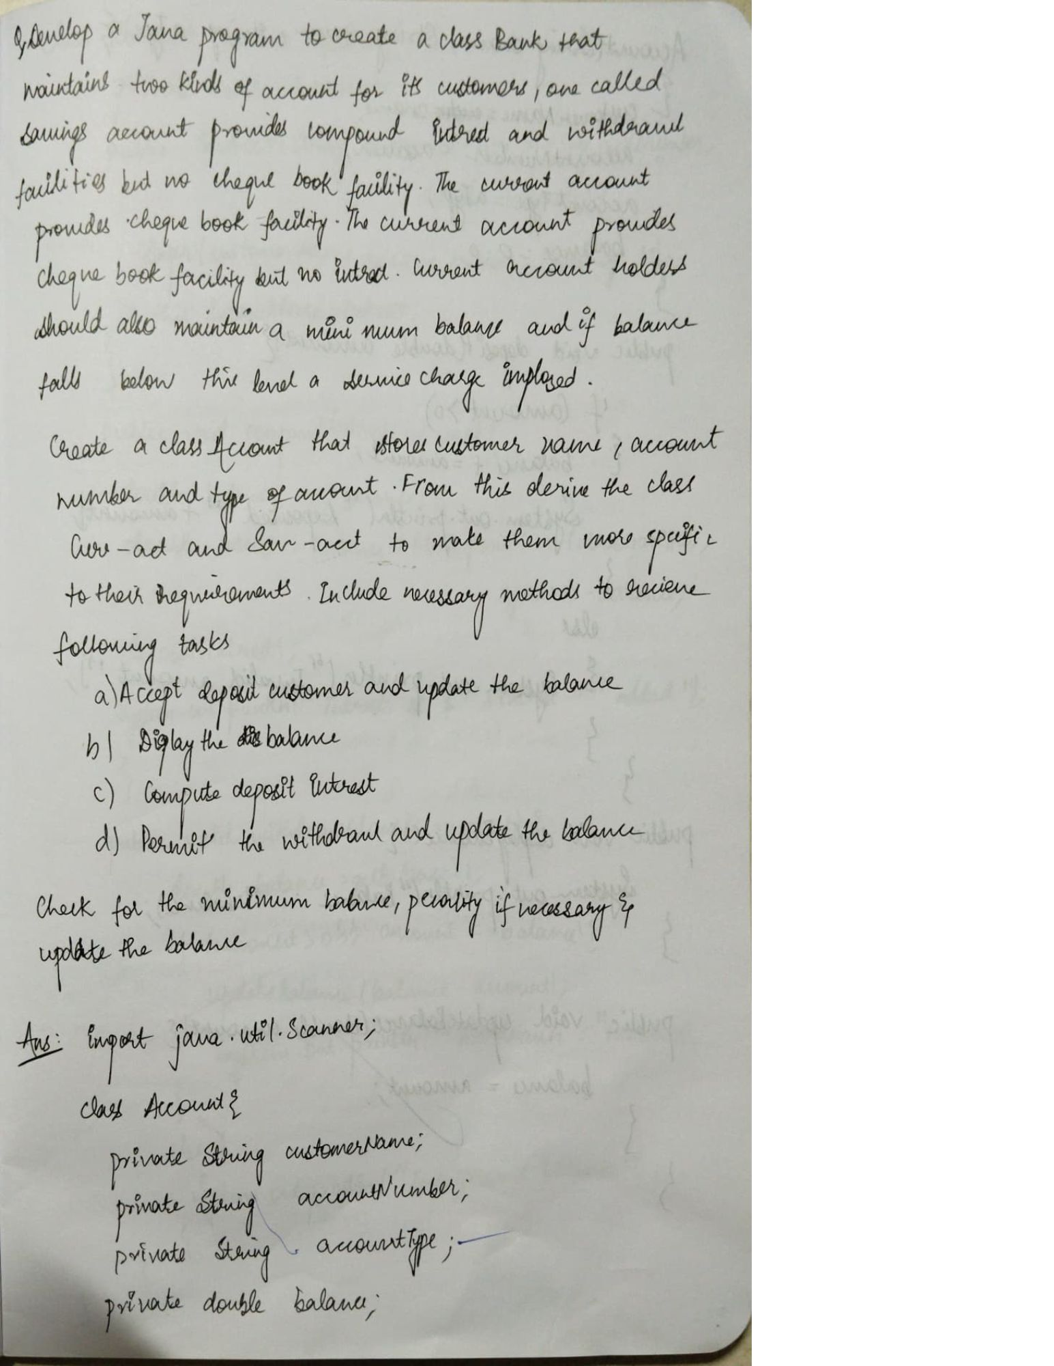

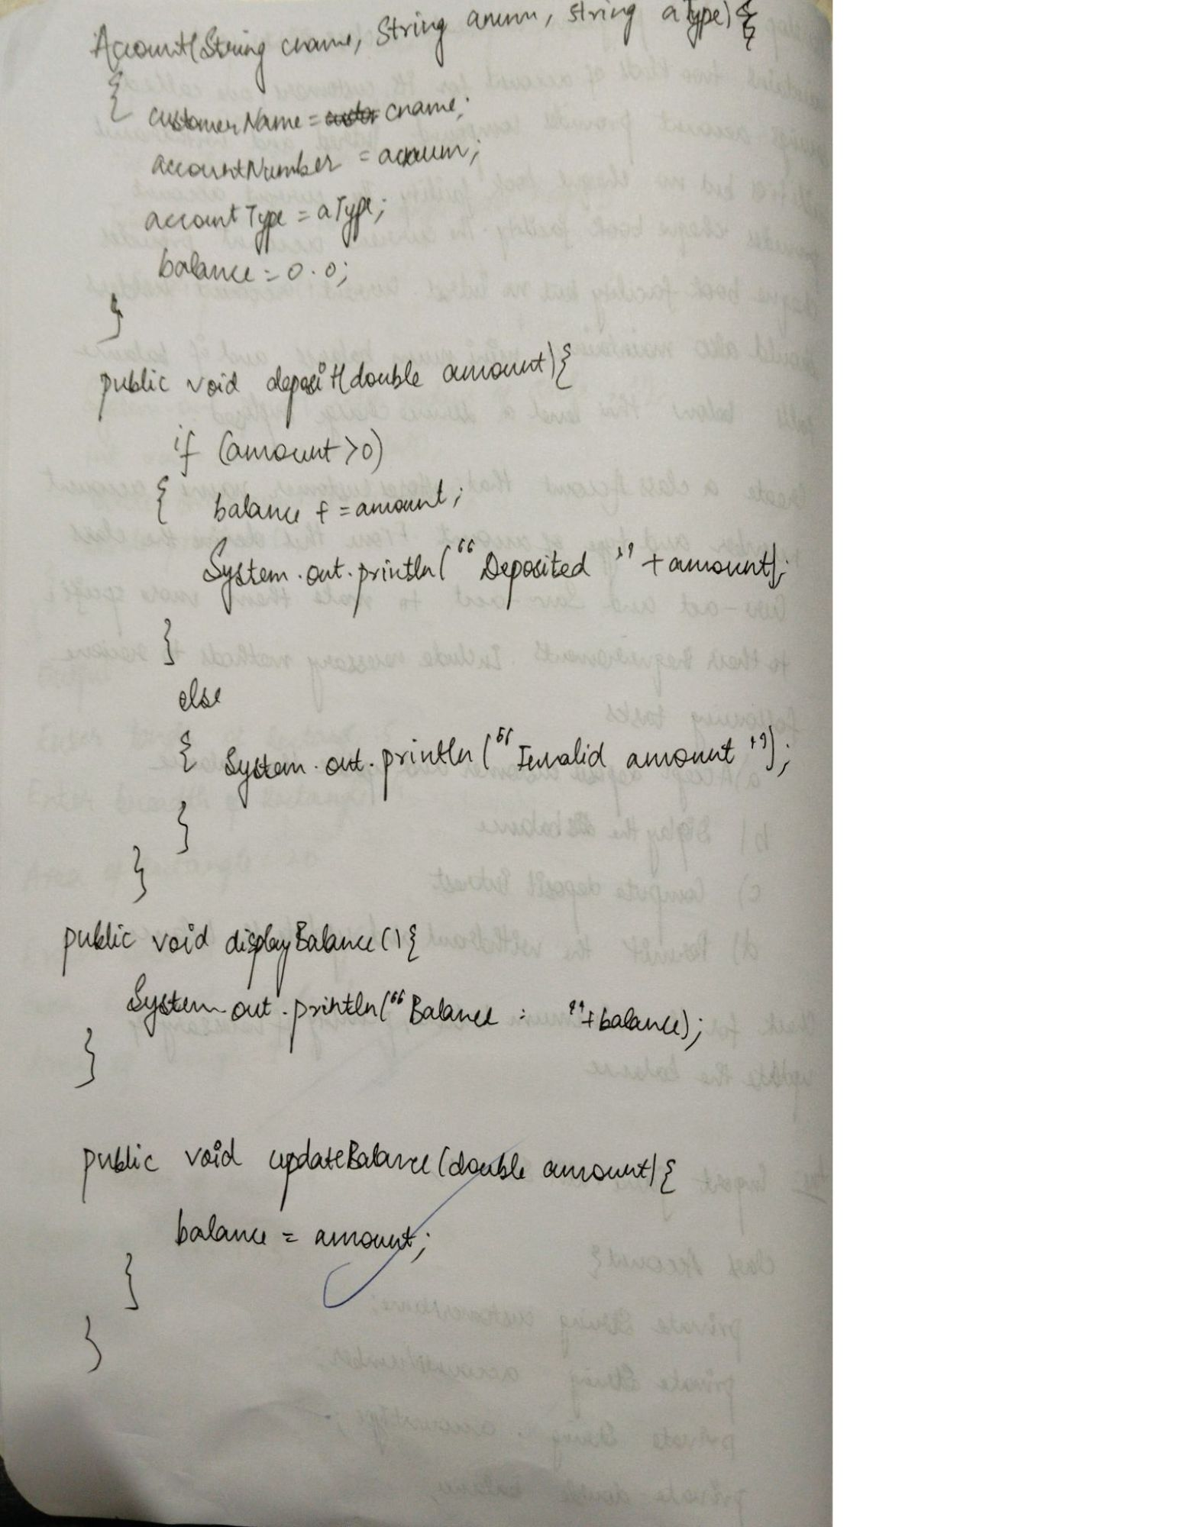

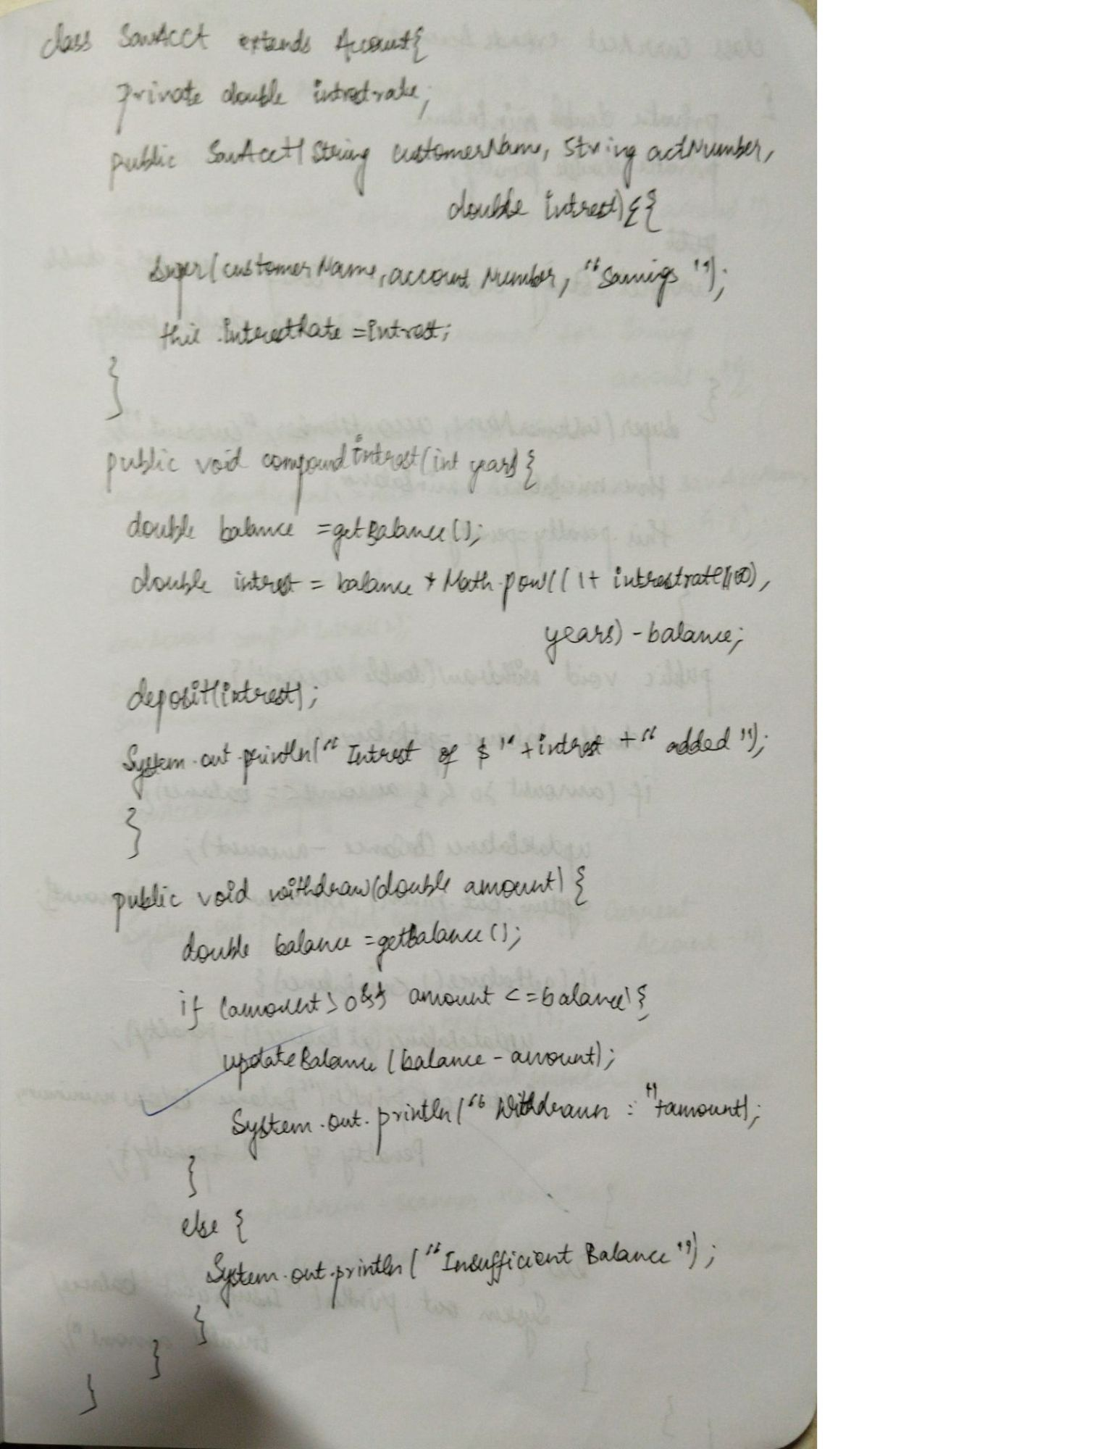

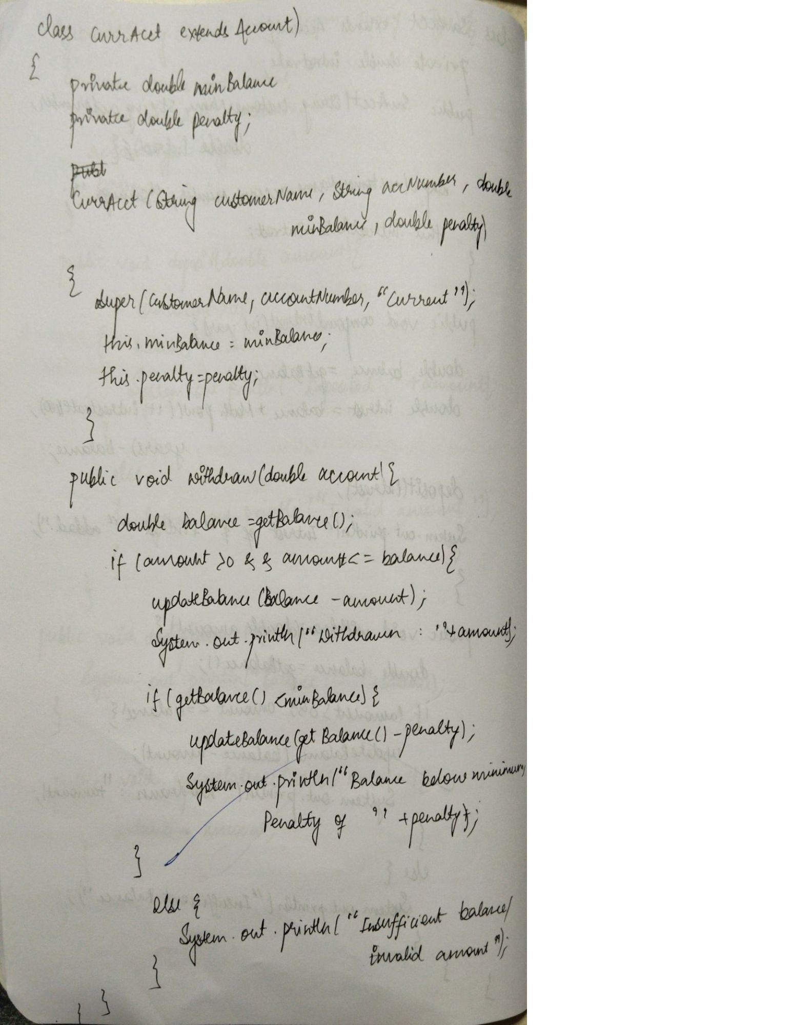

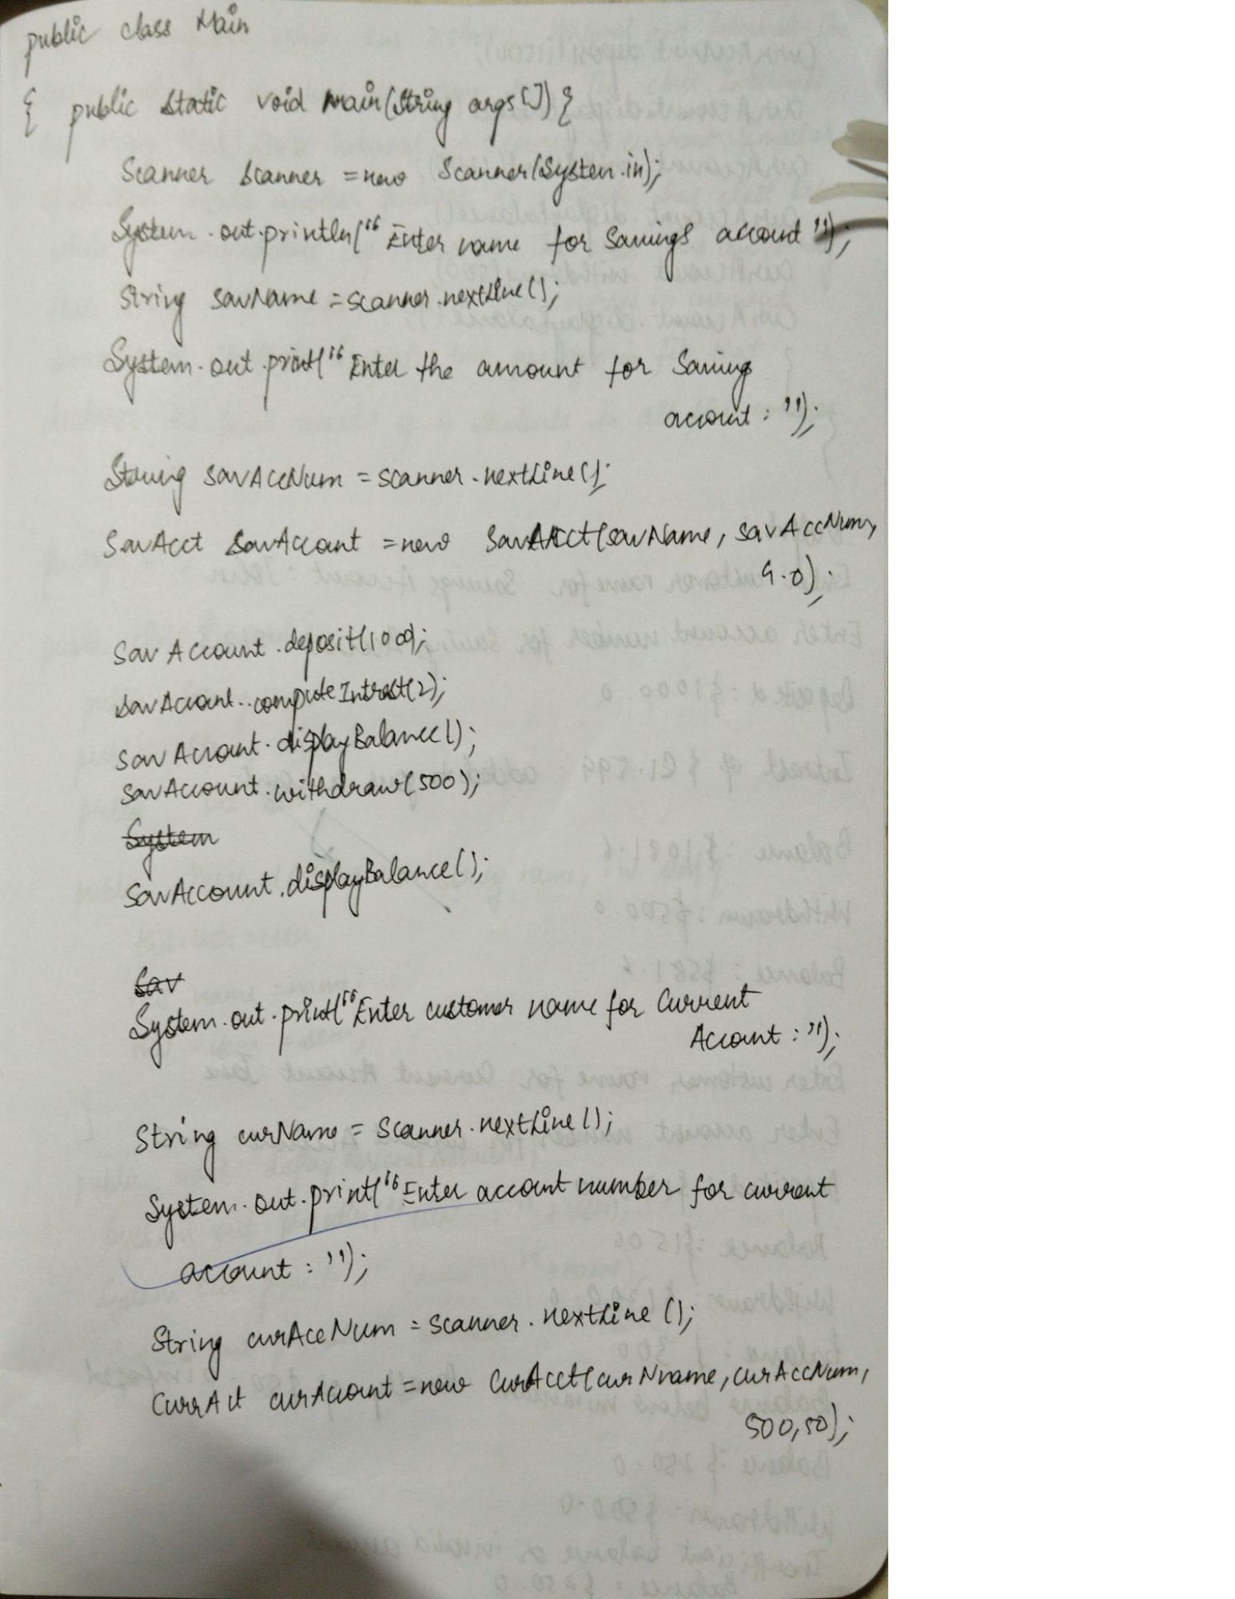

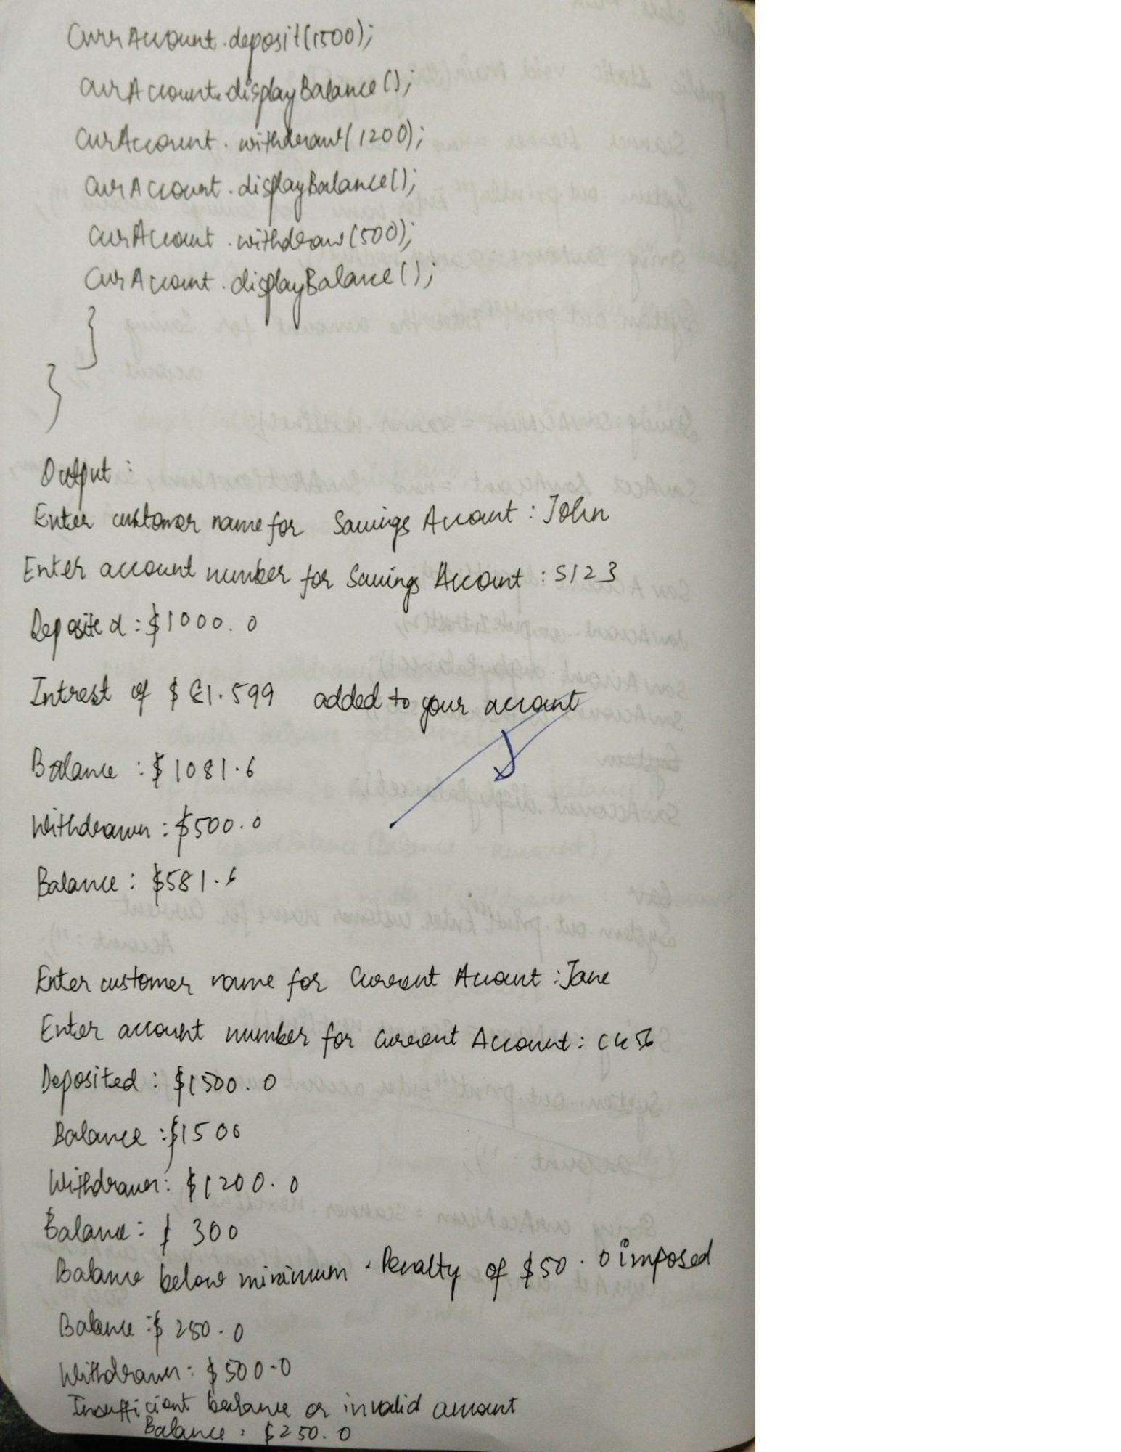

Q6. Create a package CIE which has two classes - Personal and

Internals. The class Personal has members like usn, name,

sem. The class Internals has an array that stores the

internal marks scored in five courses of the current

semester of the student. Create another package SEE

which has the class External which is a derived class of

Personal. This class has an array that stores the SEE marks

scored in five courses of the current semester of the

student. Import the two packages in a file that declares

the final marks of n students in all five courses.

package CIE;

public class Internals {

public int[] internalMarks = new int[5];

public void setInternalMarks(int[] marks) {

for (int i = 0; i < 5; i++) {

internalMarks[i] = marks[i];

}

}

public void displayInternalMarks() {

System.out.print("Internal Marks: ");

for (int mark : internalMarks) {

System.out.print(mark + " ");

}

System.out.println();

}

}

---------------------------------------------------------------

package CIE;

public class Personal {

public String usn;

public String name;

public int sem;

public Personal(String usn, String name, int sem) {

this.usn = usn;

this.name = name;

this.sem = sem;

}

public void displayPersonalDetails() {

System.out.println("USN: " + usn);

System.out.println("Name: " + name);

System.out.println("Semester: " + sem);

}

}

---------------------------------------------------------------

package SEE;

import CIE.Personal;

public class External extends Personal {

public int[] seeMarks = new int[5];

public External(String usn, String name, int sem) {

super(usn, name, sem);

}

public void setSEEMarks(int[] marks) {

for (int i = 0; i < 5; i++) {

seeMarks[i] = marks[i];

}

}

public void displaySEEMarks() {

System.out.print("SEE Marks: ");

for (int mark : seeMarks) {

System.out.print(mark + " ");

}

System.out.println();

}

}

---------------------------------------------------------------

import CIE.*;

import SEE.*;

import java.util.Scanner;

public class Main {

public static void main(String[] args) {

Scanner scanner = new Scanner(System.in);

System.out.print("Enter number of students: ");

int n = scanner.nextInt();

// Create arrays for objects

External[] students = new External[n];

Internals[] internals = new Internals[n];

// Input details for each student

for (int i = 0; i < n; i++) {

System.out.println("\nEnter details for student " + (i + 1) + ":");

// Input personal details

System.out.print("Enter USN: ");

String usn = scanner.next();

System.out.print("Enter Name: ");

String name = scanner.next();

System.out.print("Enter Semester: ");

int sem = scanner.nextInt();

// Create objects

students[i] = new External(usn, name, sem);

internals[i] = new Internals();

// Input internal marks

System.out.println("Enter 5 internal marks: ");

int[] internalMarks = new int[5];

for (int j = 0; j < 5; j++) {

internalMarks[j] = scanner.nextInt();

}

internals[i].setInternalMarks(internalMarks);

// Input SEE marks

System.out.println("Enter 5 SEE marks: ");

int[] seeMarks = new int[5];

for (int j = 0; j < 5; j++) {

seeMarks[j] = scanner.nextInt();

}

students[i].setSEEMarks(seeMarks);

}

// Display details and calculate final marks

System.out.println("\nFinal Marks of Students:");

for (int i = 0; i < n; i++) {

System.out.println("\nStudent " + (i + 1) + ":");

students[i].displayPersonalDetails();

internals[i].displayInternalMarks();

students[i].displaySEEMarks();

System.out.print("Final Marks: ");

for (int j = 0; j < 5; j++) {

int finalMarks = internals[i].internalMarks[j] + (students[i].seeMarks[j] / 2);

System.out.print(finalMarks + " ");

}

System.out.println();

}

scanner.close();

}

}

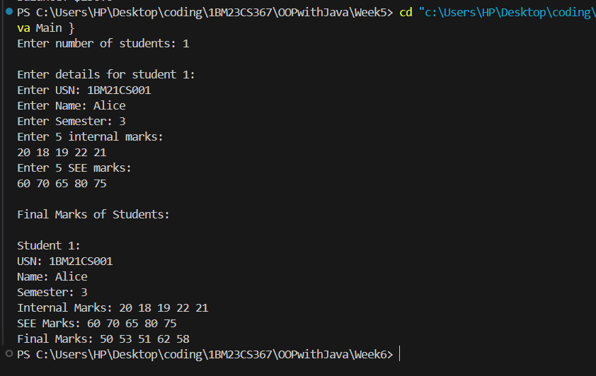

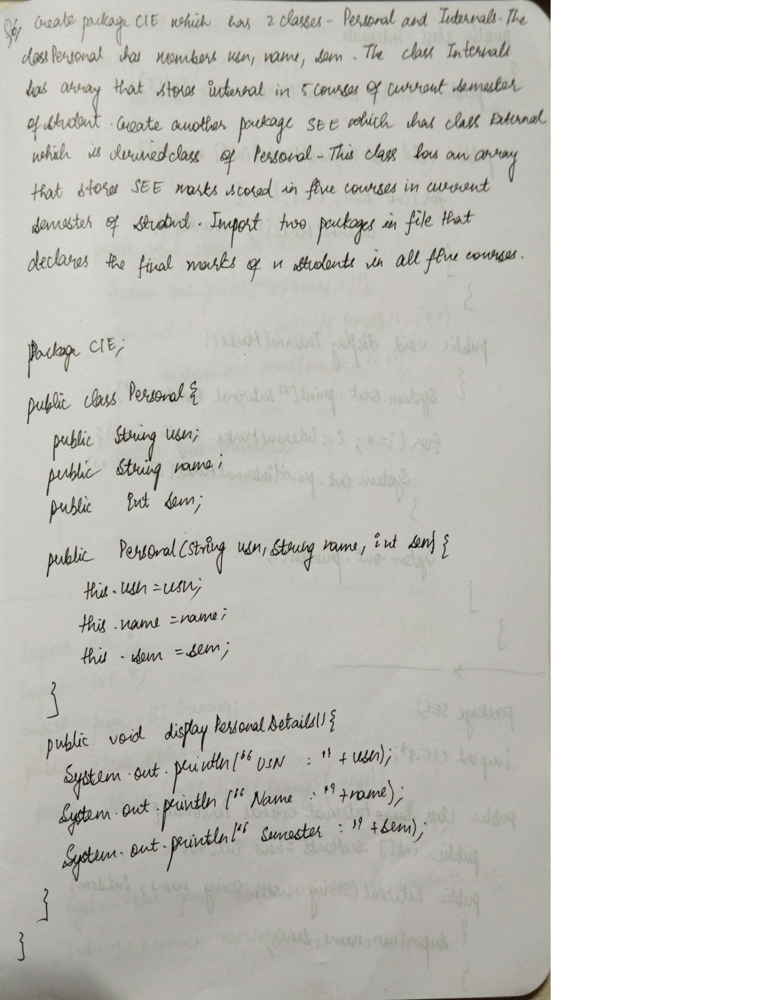

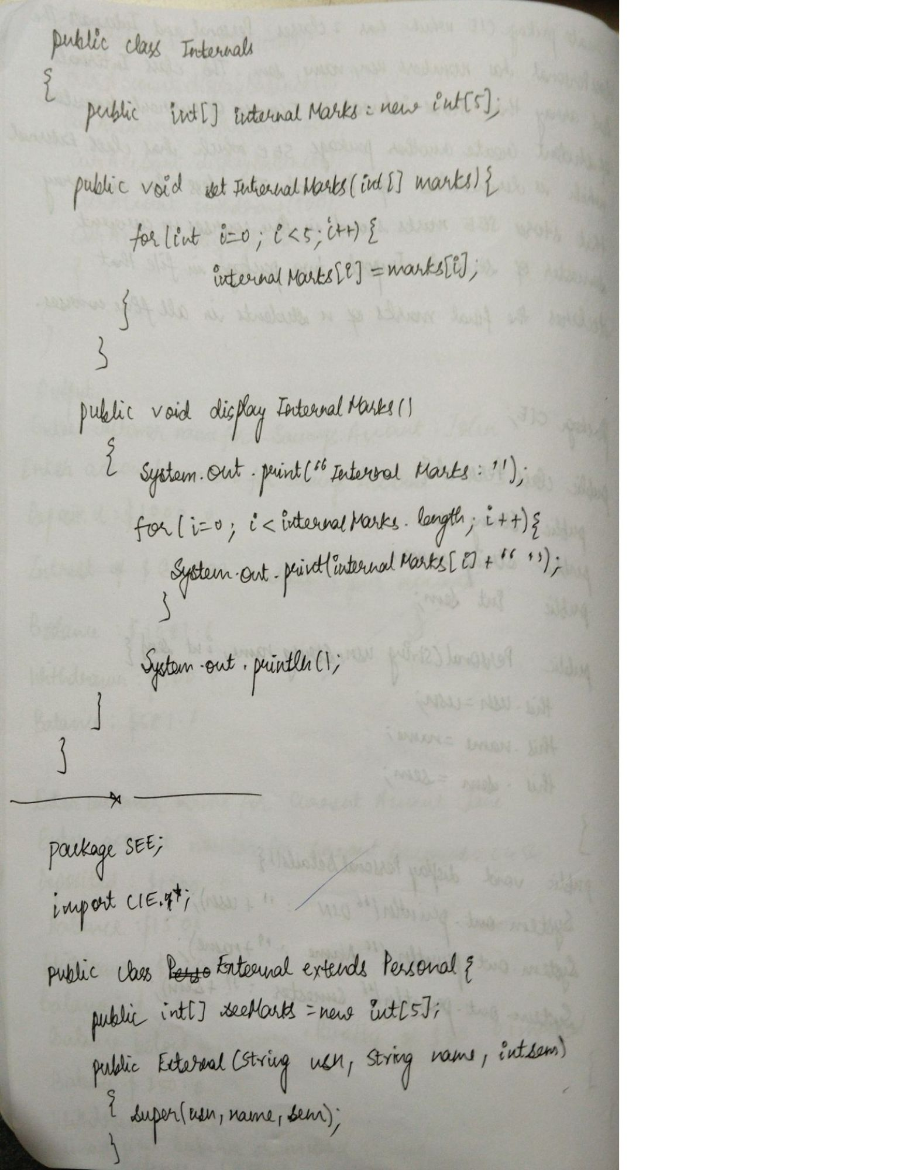

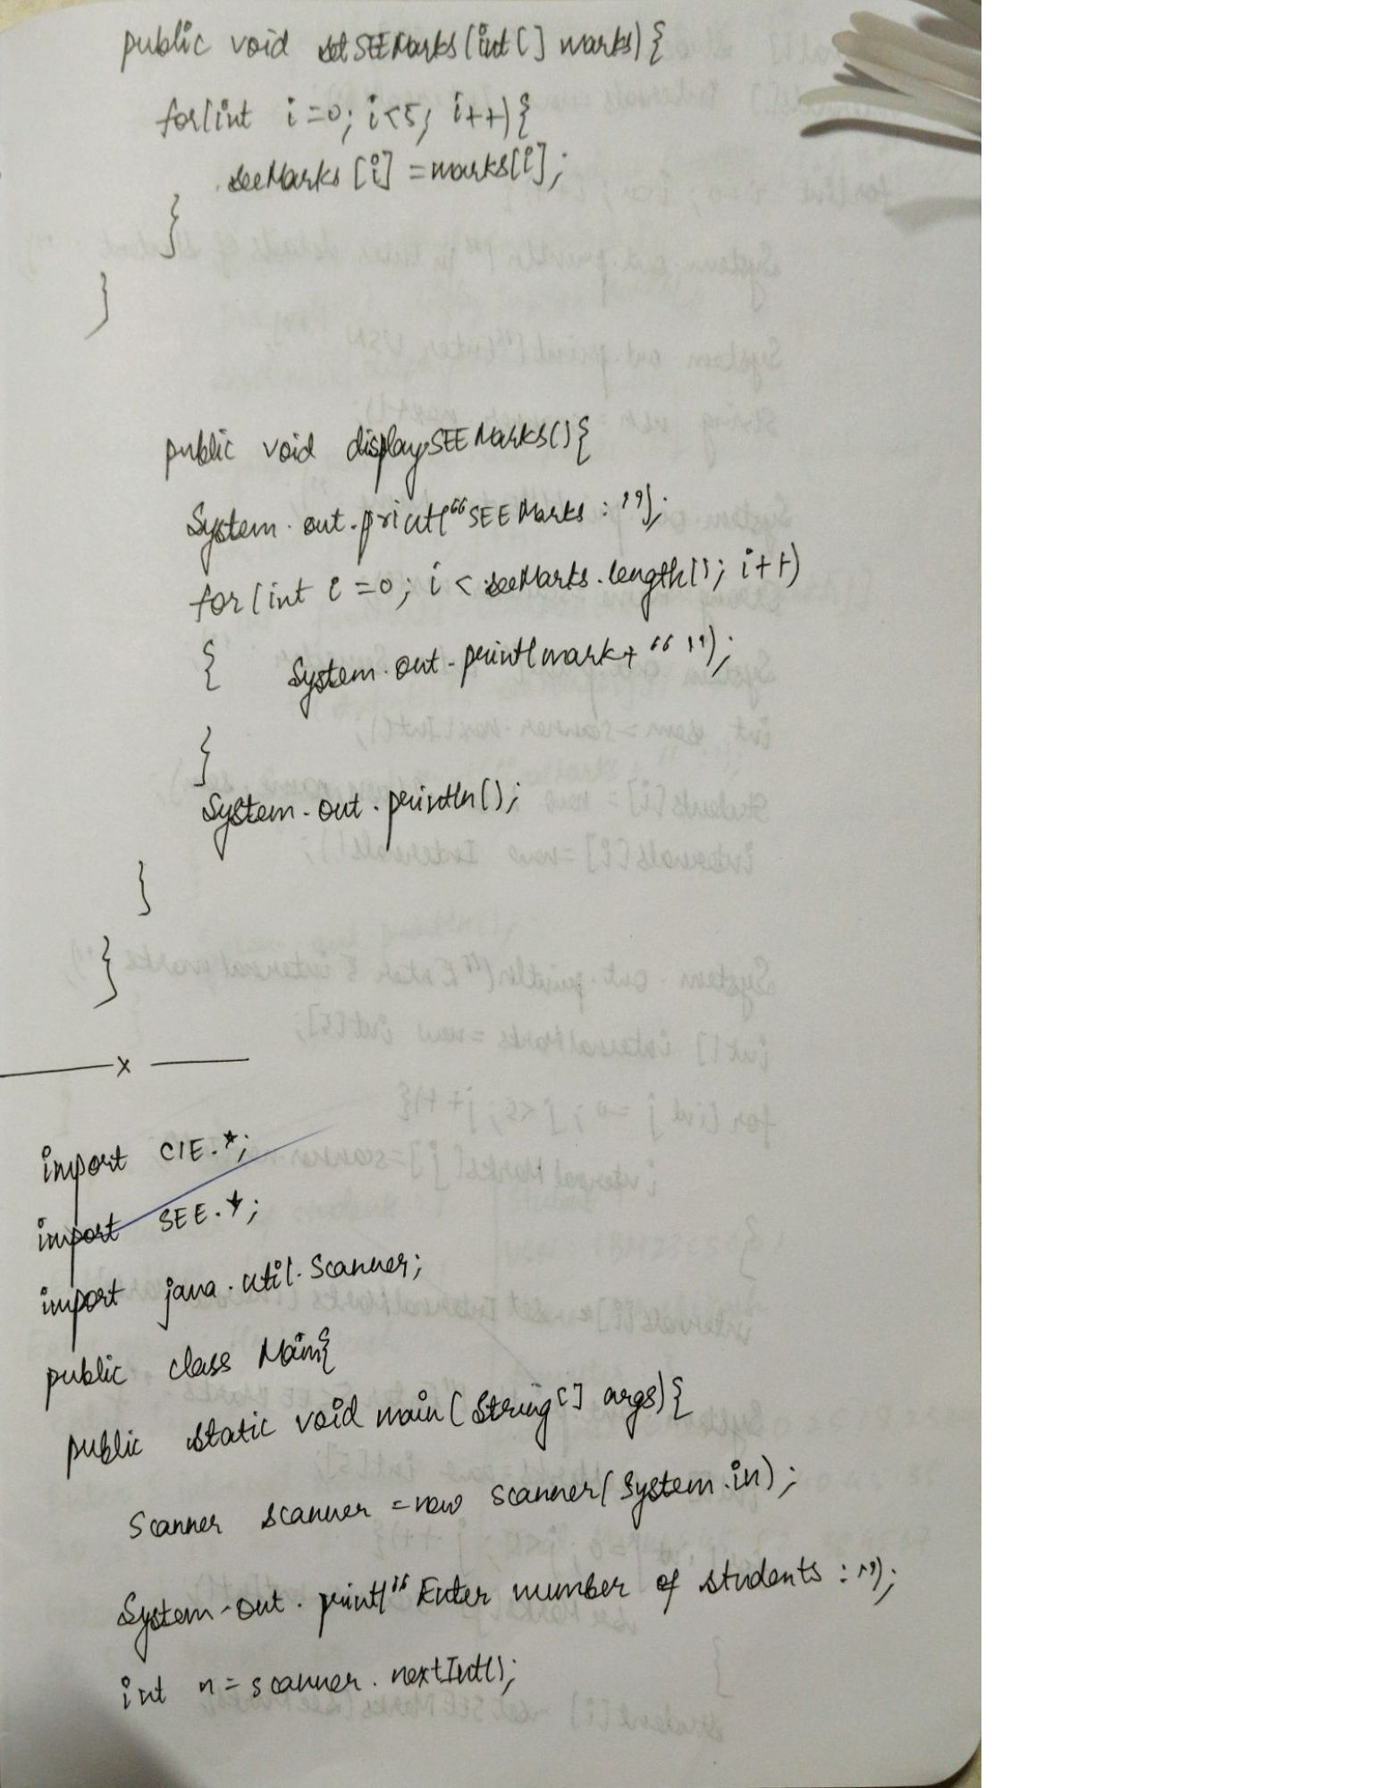

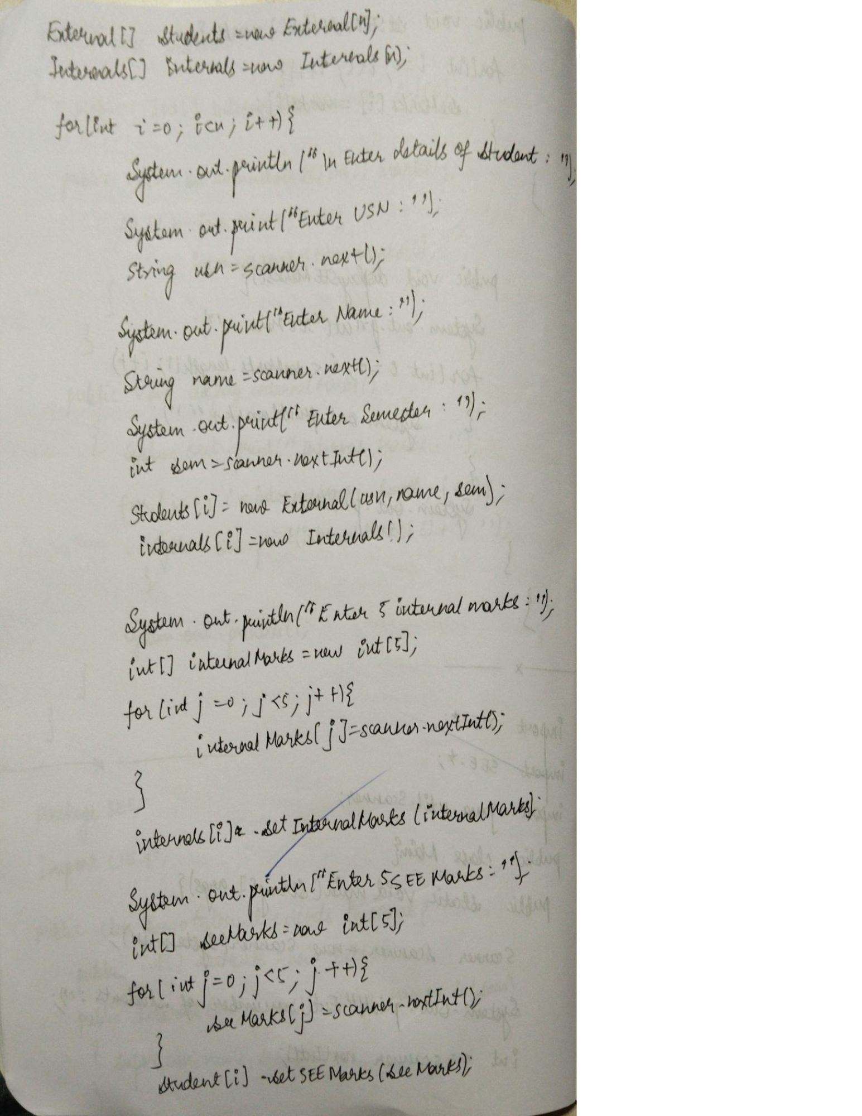

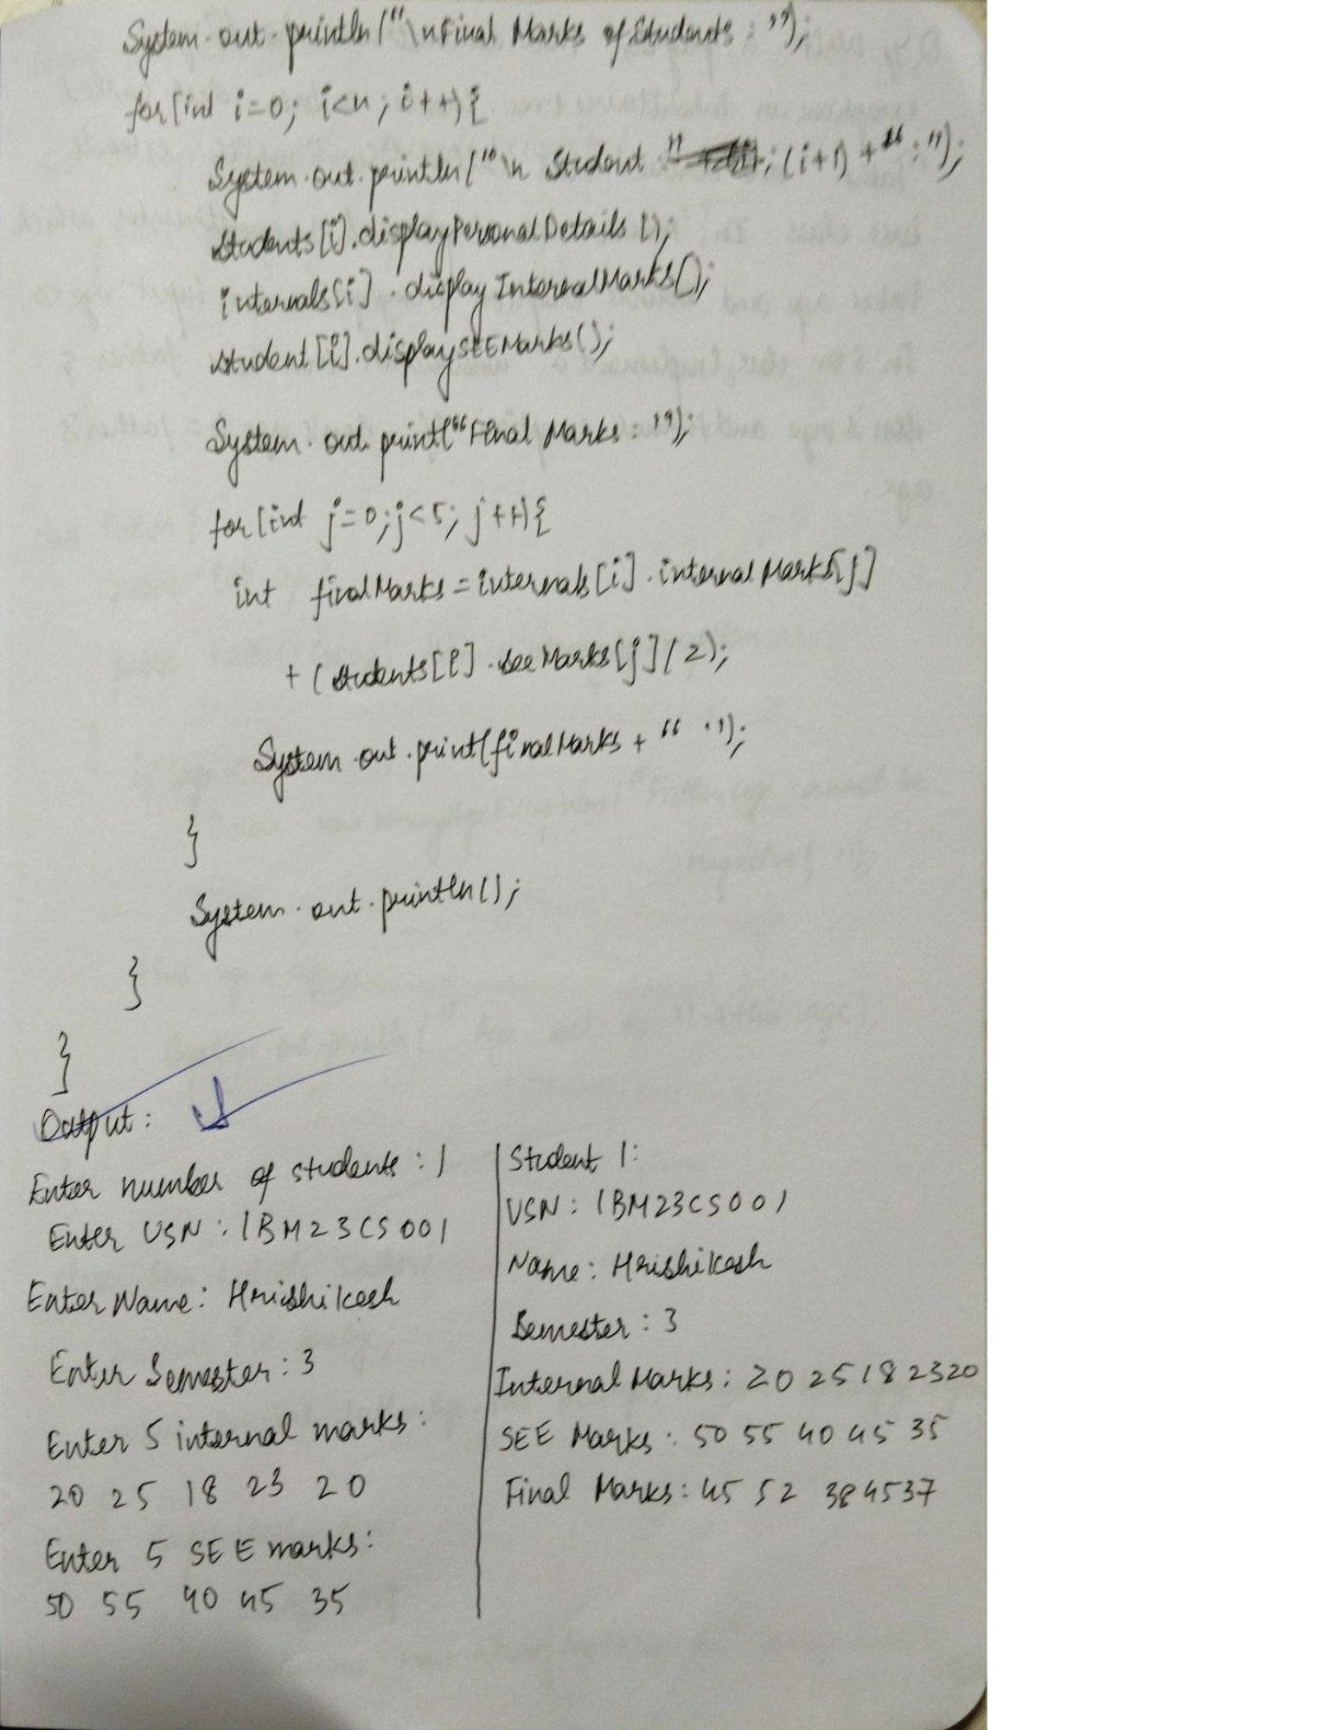

Q7. Write a program that demonstrates handling of

exceptions in inheritance tree. Create a base class called

“Father” and derived class called “Son” which extends the

base class. In Father class, implement a constructor which

takes the age and throws the exception WrongAge( ) when

the input age<0. In Son class, implement a constructor

that uses both father and son’s age and throws an

exception if son’s age is >=father’s age.

import java.util.Scanner;

class WrongAgeException extends Exception {

public WrongAgeException(String message) {

super(message);

}

}

class Father {

protected int age;

public Father(int age) throws WrongAgeException {

if (age < 0) {

throw new WrongAgeException("Father's age cannot be negative!");

}

this.age = age;

System.out.println("Father's age is set to: " + this.age);

}

}

class Son extends Father {

private int sonAge;

public Son(int fatherAge, int sonAge) throws WrongAgeException {

super(fatherAge);

if (sonAge < 0) {

throw new WrongAgeException("Son's age cannot be negative!");

}

if (sonAge >= fatherAge) {

throw new WrongAgeException("Son's age cannot be greater than or equal to Father's age!");

}

this.sonAge = sonAge;

System.out.println("Son's age is set to: " + this.sonAge);

}

}

public class Main {

public static void main(String[] args) {

Scanner scanner = new Scanner(System.in);

try {

System.out.print("Enter Father's age: ");

int fatherAge = scanner.nextInt();

System.out.print("Enter Son's age: ");

int sonAge = scanner.nextInt();

Son son = new Son(fatherAge, sonAge);

} catch (WrongAgeException e) {

System.out.println("Exception occurred: " + e.getMessage());

} catch (Exception e) {

System.out.println("An unexpected error occurred: " + e.getMessage());

} finally {

scanner.close();

System.out.println("Program execution completed.");

}

}

}

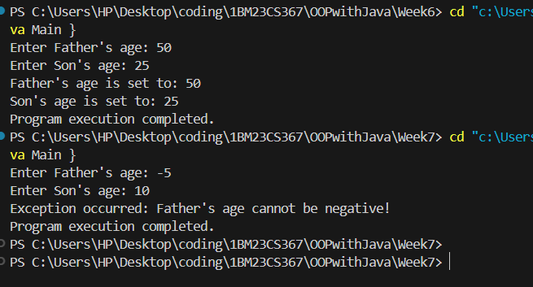

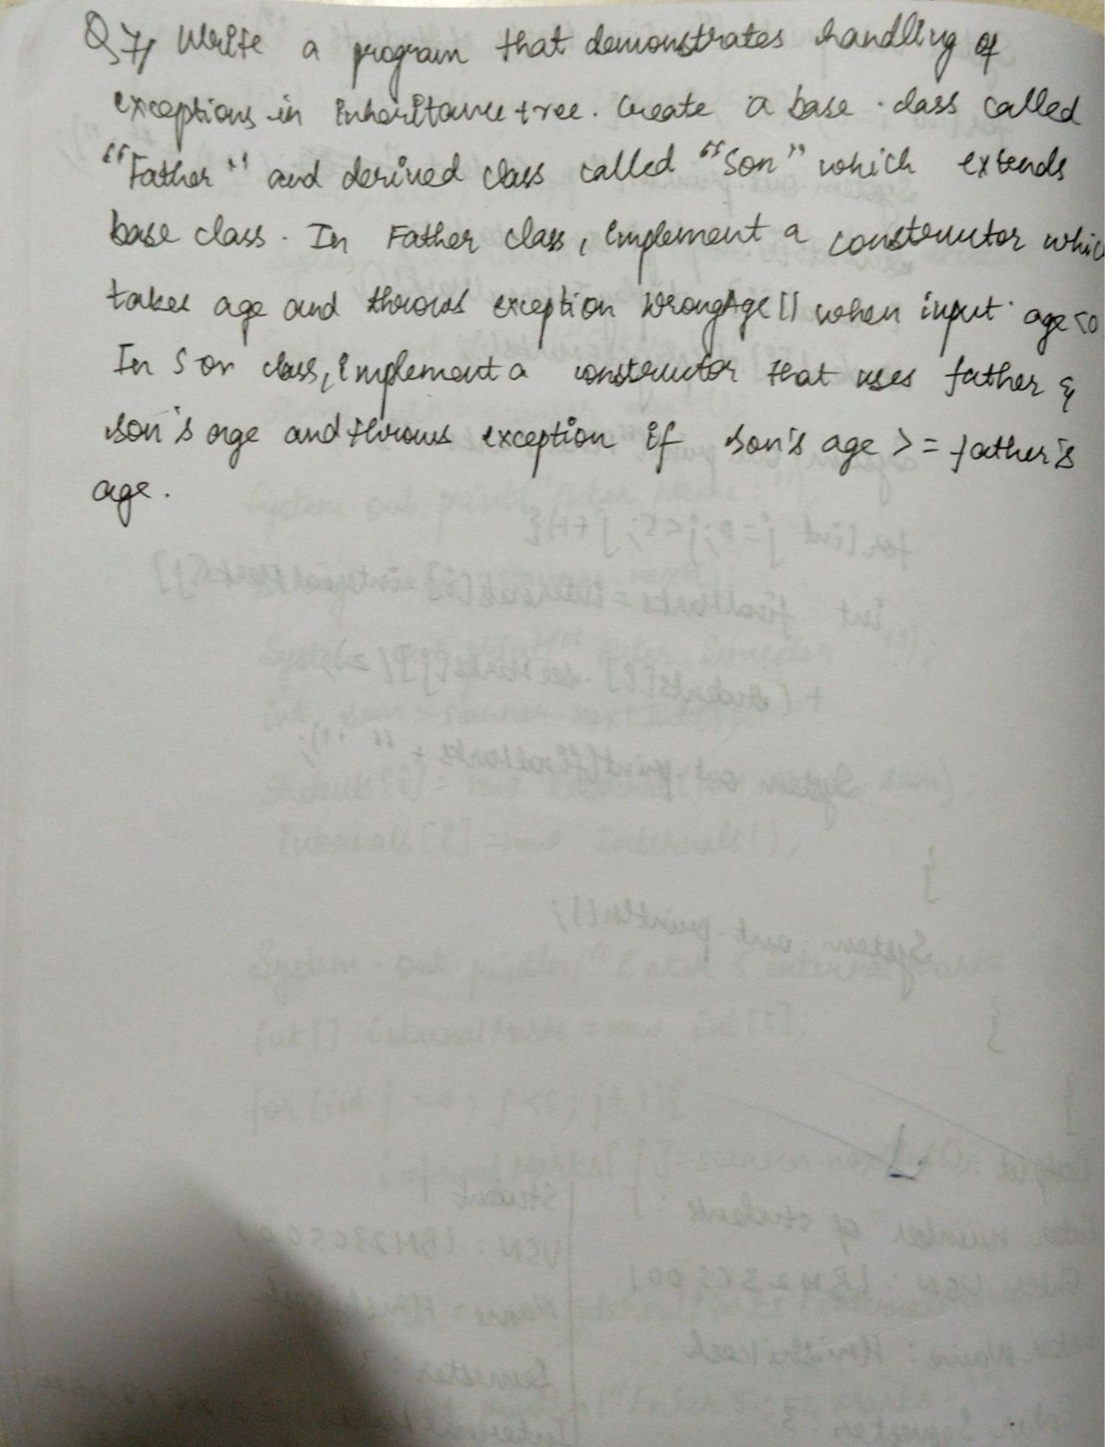

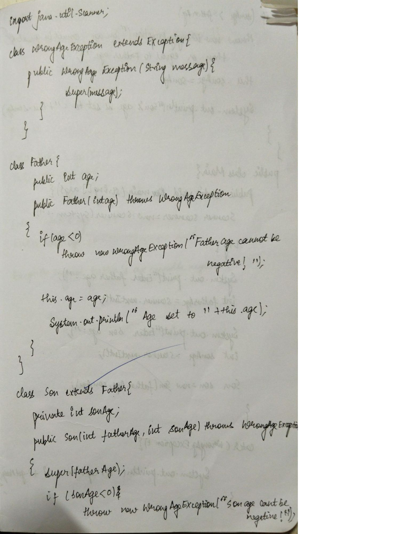

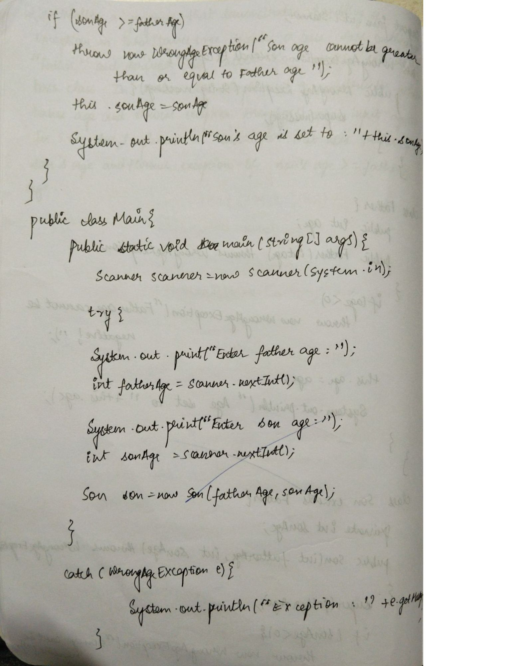

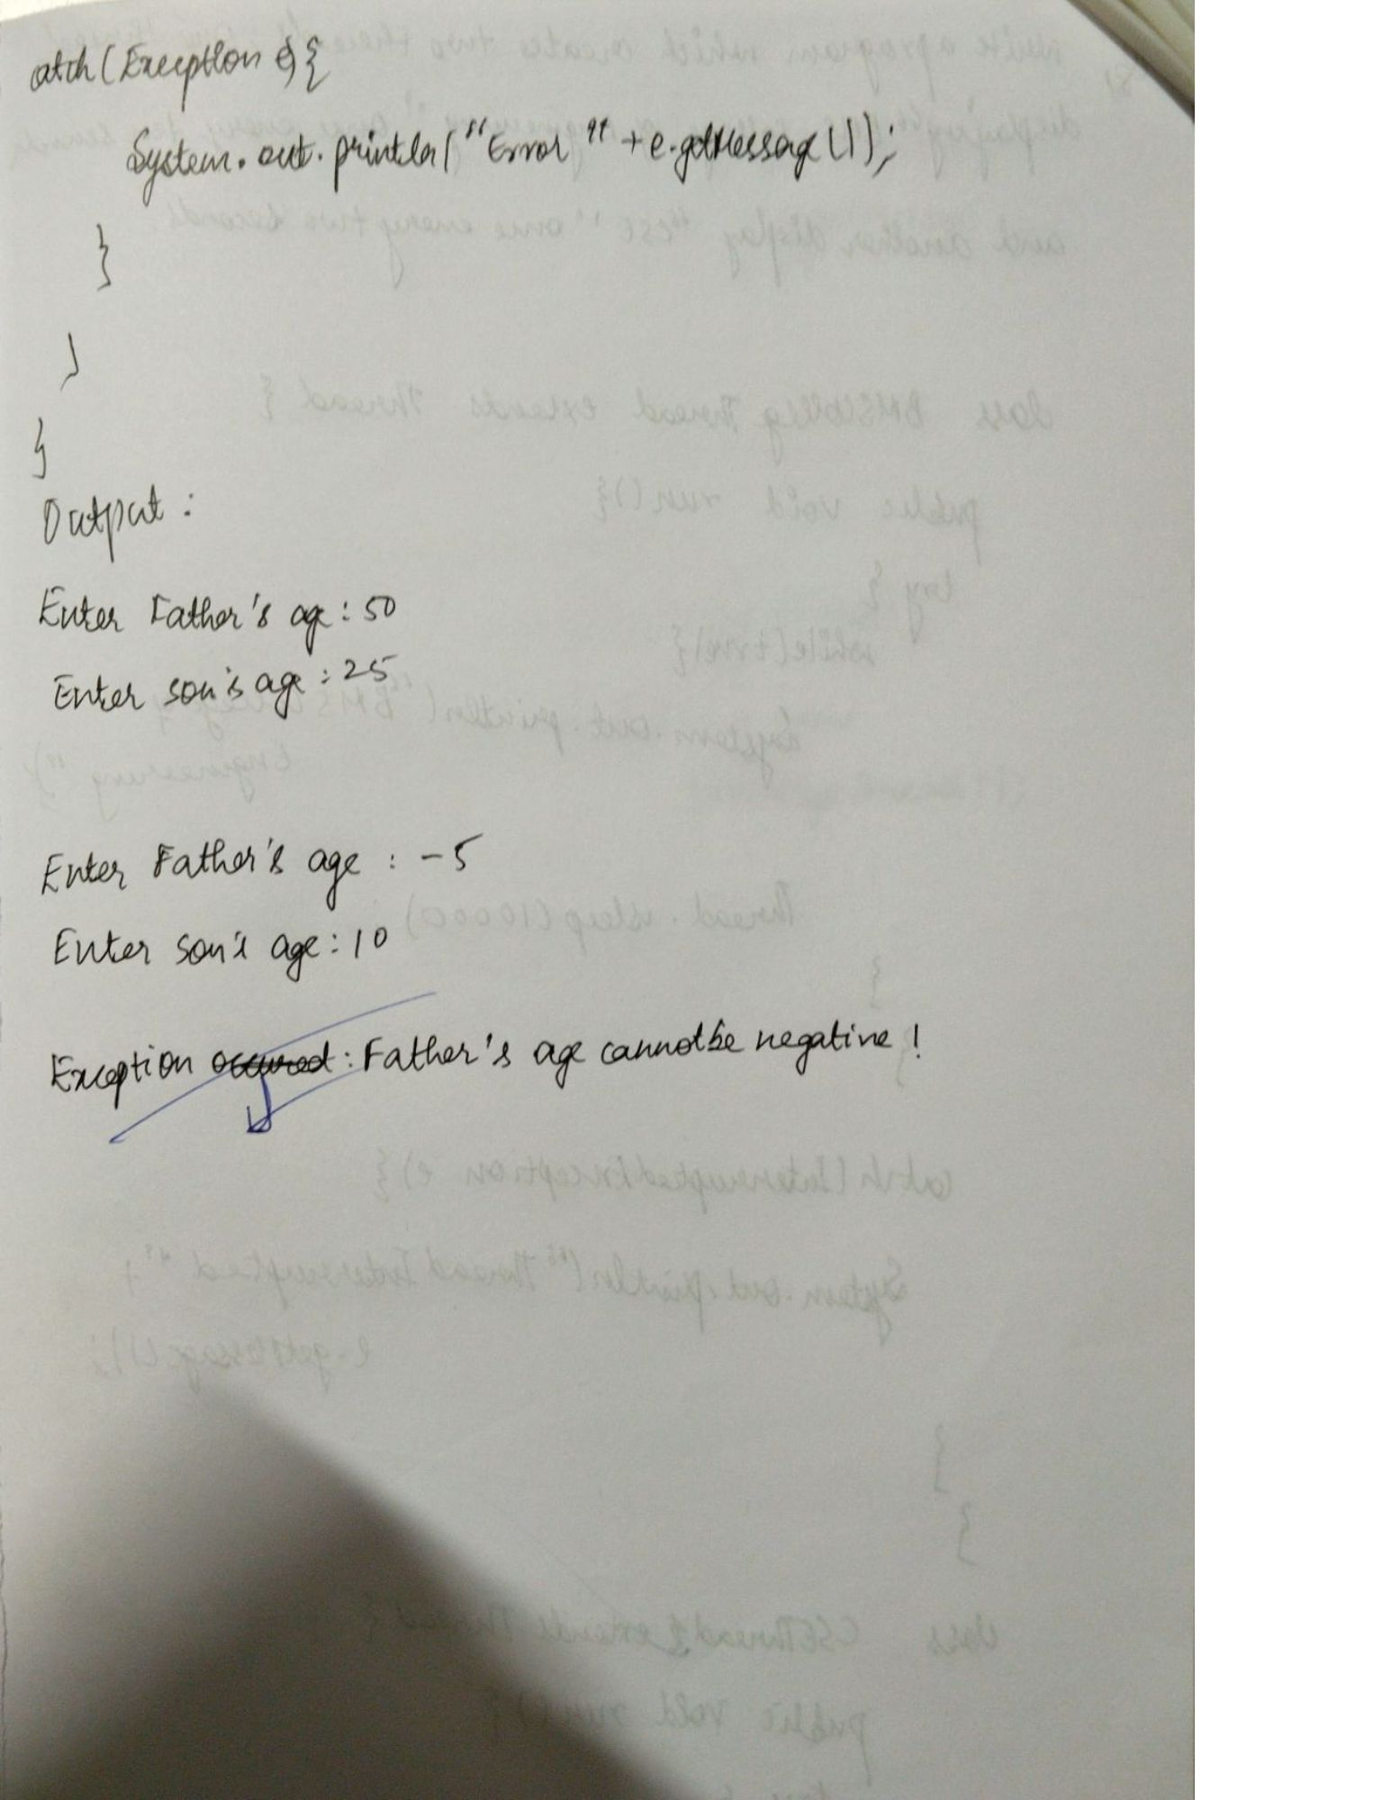

Q8. Write a program which creates two threads, one thread displaying “BMS College of Engineering” once every ten seconds and another displaying “CSE” once every two seconds.

class BMSCollegeThread extends Thread{

public void run(){

try {

for(int i=0;i<2;i++){

System.out.println("BMS College of Engineering");

Thread.sleep(10000);

}

} catch (InterruptedException e) {

System.out.println("Thread Interrupted "+e.getMessage());

}

}

}

class CSEThread extends Thread{

public void run(){

try {

for(int i=0;i<10;i++){

System.out.println("CSE");

Thread.sleep(2000);

}

}

catch (InterruptedException e) {

System.out.println("Thread Interrupted "+e.getMessage());

}

}

}

public class MultiThreadExample {

public static void main(String[] args) {

BMSCollegeThread bms = new BMSCollegeThread();

CSEThread cse = new CSEThread();

bms.start();

cse.start();

}

}

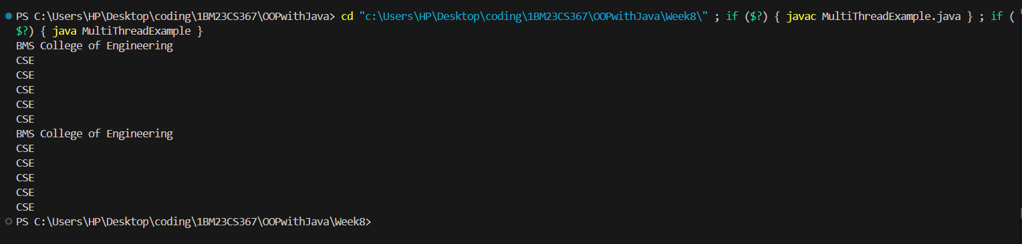

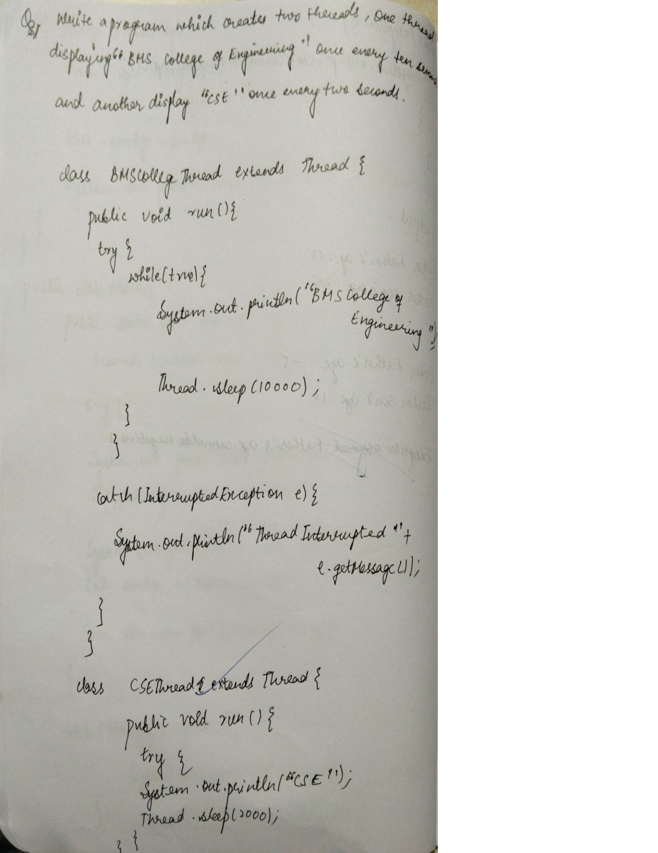

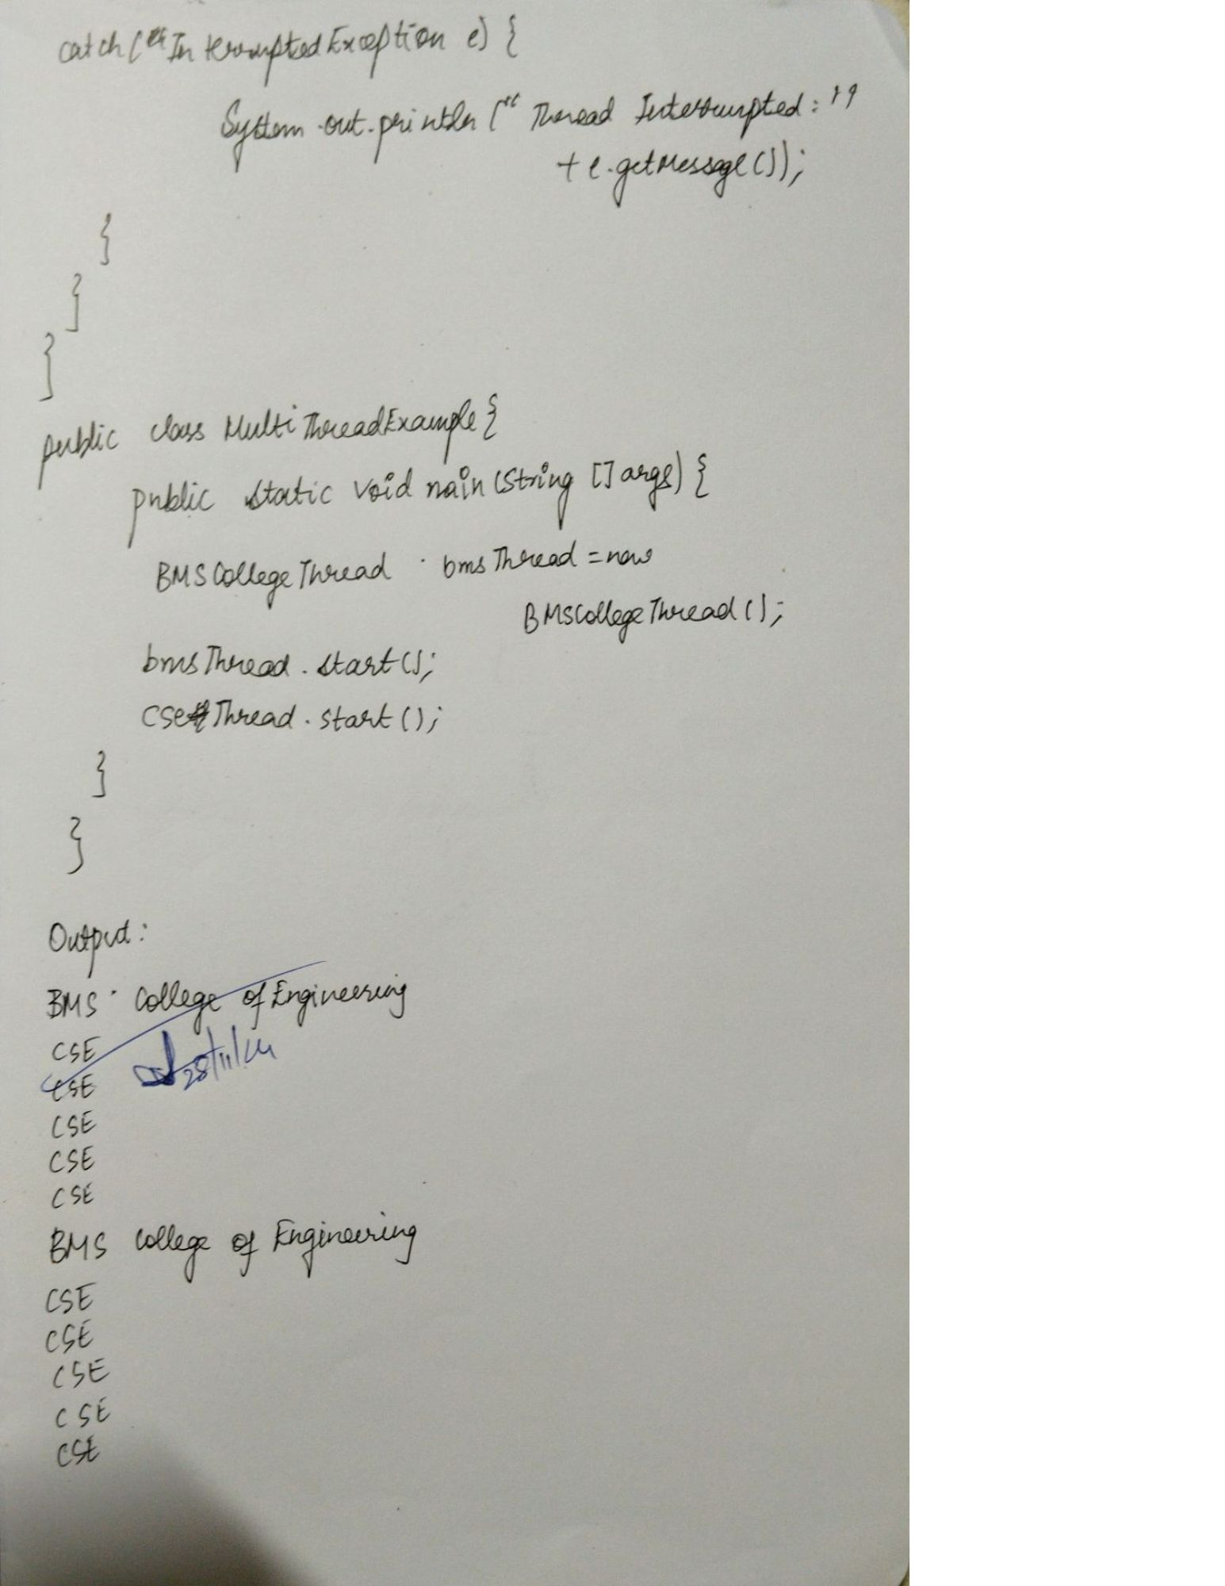

Open Ended Exercise 1: Write a program that creates a user interface to perform integer divisions. The user enters two numbers in the text fields, Num1 and Num2. The division of Num1 and Num2 is displayed in the Result field when the Divide button is clicked. If Num1 or Num2 were not an integer, the program would throw a NumberFormatException. If Num2 were Zero, the program would throw an Arithmetic Exception Display the exception in a message dialog box.

import java.swing.*; import java.awt.*; import java.awt.event.ActionEvent; import java.awt.event.ActionListener;

public class IntegerDivisionApp { public static void main(String[] args) { // Create the main frame JFrame frame = new JFrame("Integer Division"); frame.setDefaultCloseOperation(JFrame.EXIT_ON_CLOSE); frame.setSize(400, 200); frame.setLayout(new GridLayout(4, 2, 10, 10));

// Create and add components  
 JLabel labelNum1 = new JLabel("Num1:");  
 JTextField textNum1 = new JTextField();  
 JLabel labelNum2 = new JLabel("Num2:");  
 JTextField textNum2 = new JTextField();  
 JLabel labelResult = new JLabel("Result:");  
 JTextField textResult = new JTextField();  
 textResult.setEditable(false);  
 JButton divideButton = new JButton("Divide");  
  
 // Add components to the frame  
 frame.add(labelNum1);  
 frame.add(textNum1);  
 frame.add(labelNum2);  
 frame.add(textNum2);  
 frame.add(labelResult);  
 frame.add(textResult);  
 frame.add(new JLabel()); // Empty cell  
 frame.add(divideButton);  
  
 // Add action listener to the button  
 divideButton.addActionListener(new ActionListener() {  
 @Override  
 public void actionPerformed(ActionEvent e) {  
 try {  
 // Parse inputs  
 int num1 = Integer.parseInt(textNum1.getText());  
 int num2 = Integer.parseInt(textNum2.getText());  
  
 // Perform division  
 if (num2 == 0) {  
 throw new ArithmeticException("Division by zero is not allowed.");  
 }  
  
 int result = num1 / num2;  
 textResult.setText(String.valueOf(result));  
 } catch (NumberFormatException ex) {  
 JOptionPane.showMessageDialog(frame,  
 "Please enter valid integers for Num1 and Num2.",  
 "Number Format Error",  
 JOptionPane.ERROR_MESSAGE);  
 } catch (ArithmeticException ex) {  
 JOptionPane.showMessageDialog(frame,  
 ex.getMessage(),  
 "Arithmetic Error",  
 JOptionPane.ERROR_MESSAGE);  
 }  
 }  
 });  
  
 // Make the frame visible  
 frame.setVisible(true);  
}

}

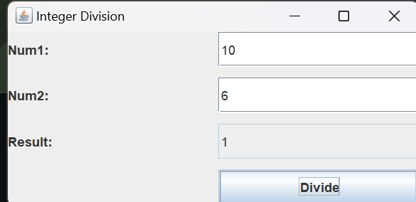

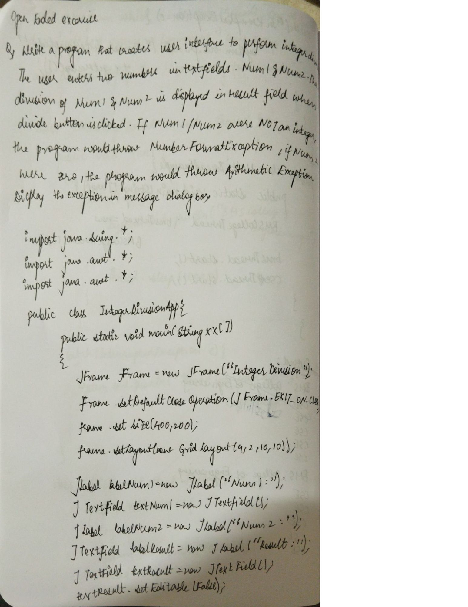

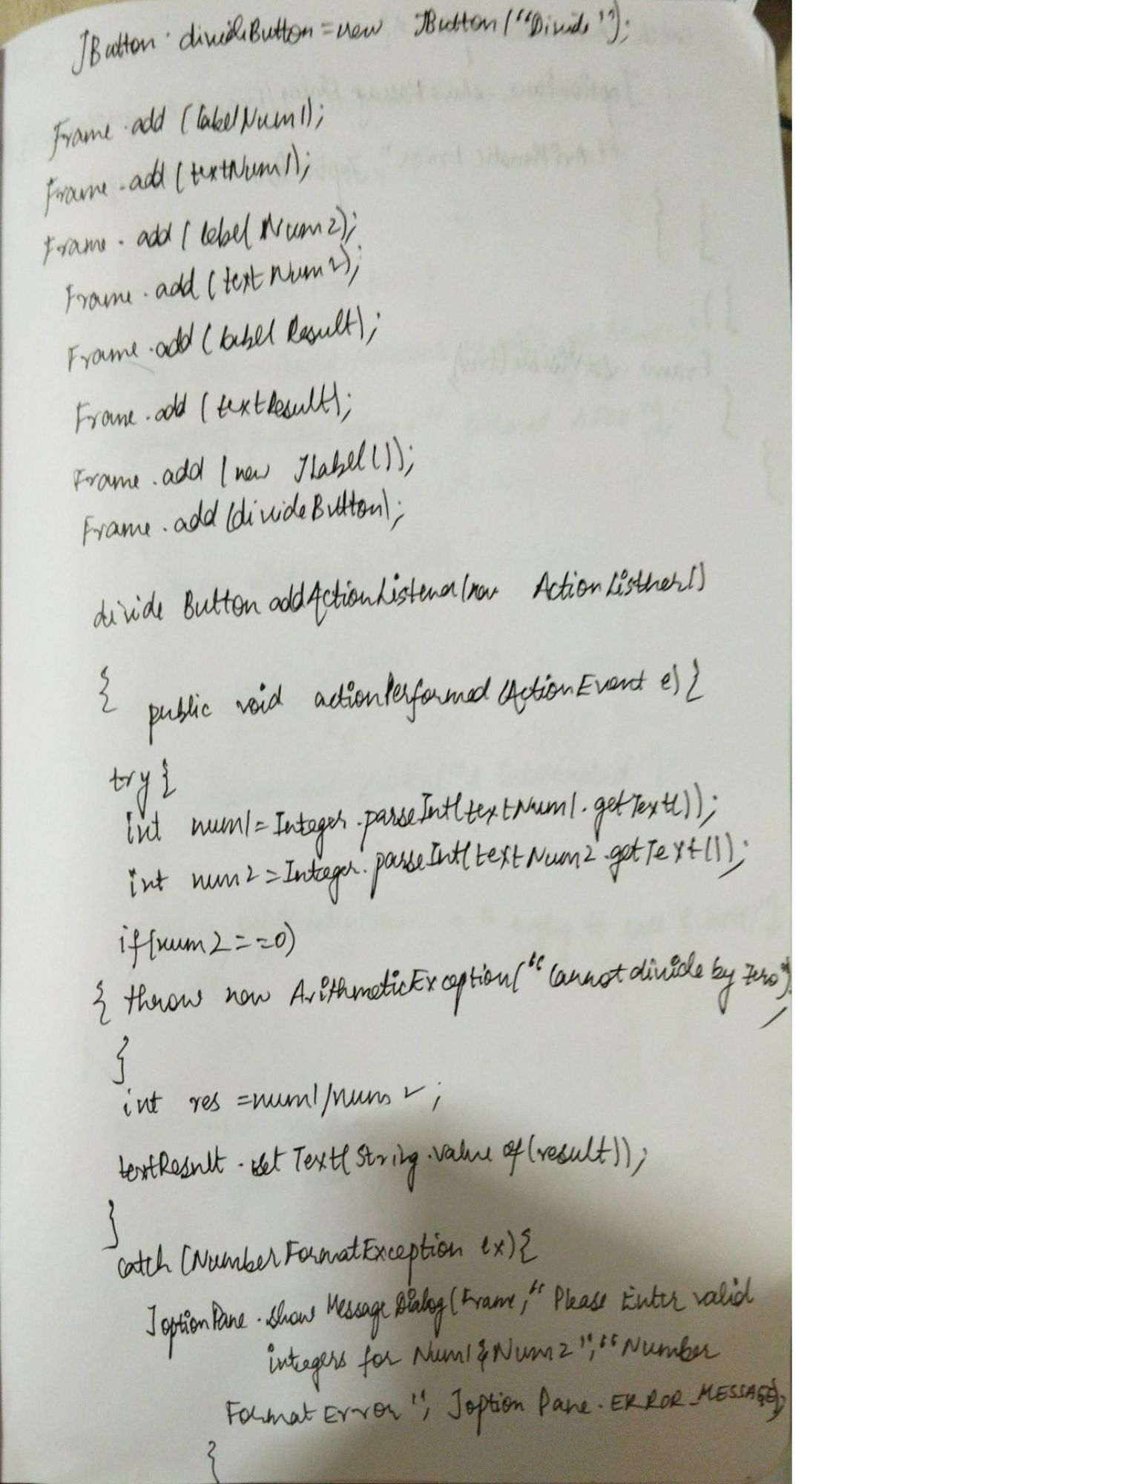

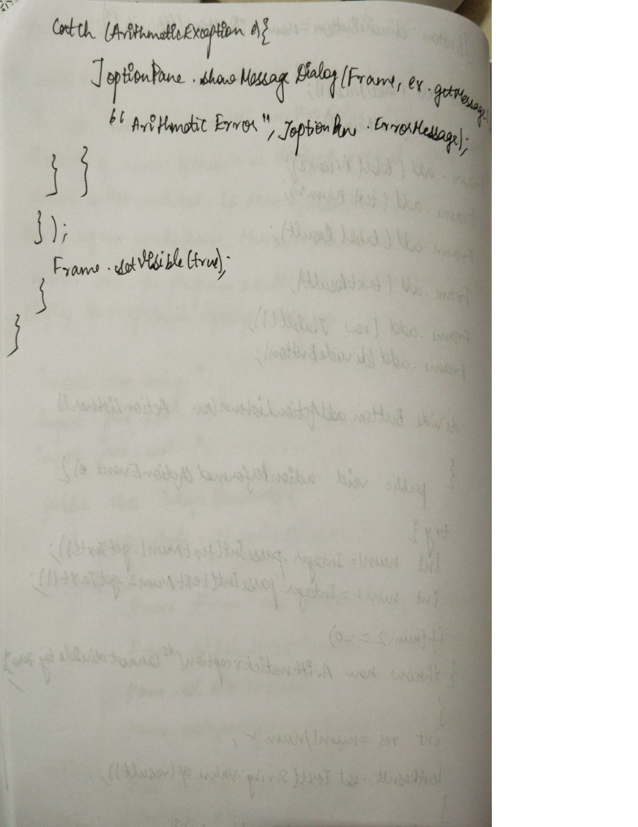

Open Ended Exercise ; Demonstrate Inter process Communication and deadlock

//Demonstrate Inter process Communication

class Q {

int n;

boolean valueSet = false;

synchronized int get() {

while (!valueSet) {

try {

wait();

} catch (InterruptedException e) {

System.out.println("InterruptedException caught");

}

}

System.out.println("Got: " + n);

valueSet = false;

notify();

return n;

}

synchronized void put(int n) {

while (valueSet) {

try {

wait();

} catch (InterruptedException e) {

System.out.println("InterruptedException caught");

}

}

this.n = n;

valueSet = true;

System.out.println("Put: " + n);

notify();

}

}

class Producer implements Runnable {

Q q;

Thread t;

Producer(Q q) {

this.q = q;

t = new Thread(this, "Producer");

}

public void run() {

int i = 0;

while (true) {

q.put(i++);

}

}

}

class Consumer implements Runnable {

Q q;

Thread t;

Consumer(Q q) {

this.q = q;

t = new Thread(this, "Consumer");

}

public void run() {

while (true) {

q.get();

}

}

}

class PCFixed {

public static void main(String args[]) {

Q q = new Q();

Producer p = new Producer(q);

Consumer c = new Consumer(q);

// Start the threads.

p.t.start();

c.t.start();

System.out.println("Press Control-C to stop.");

}

}

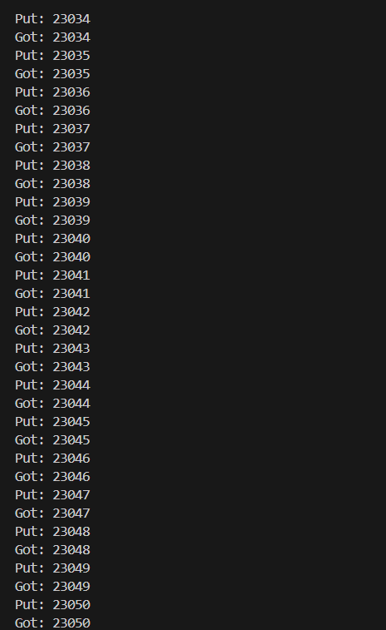

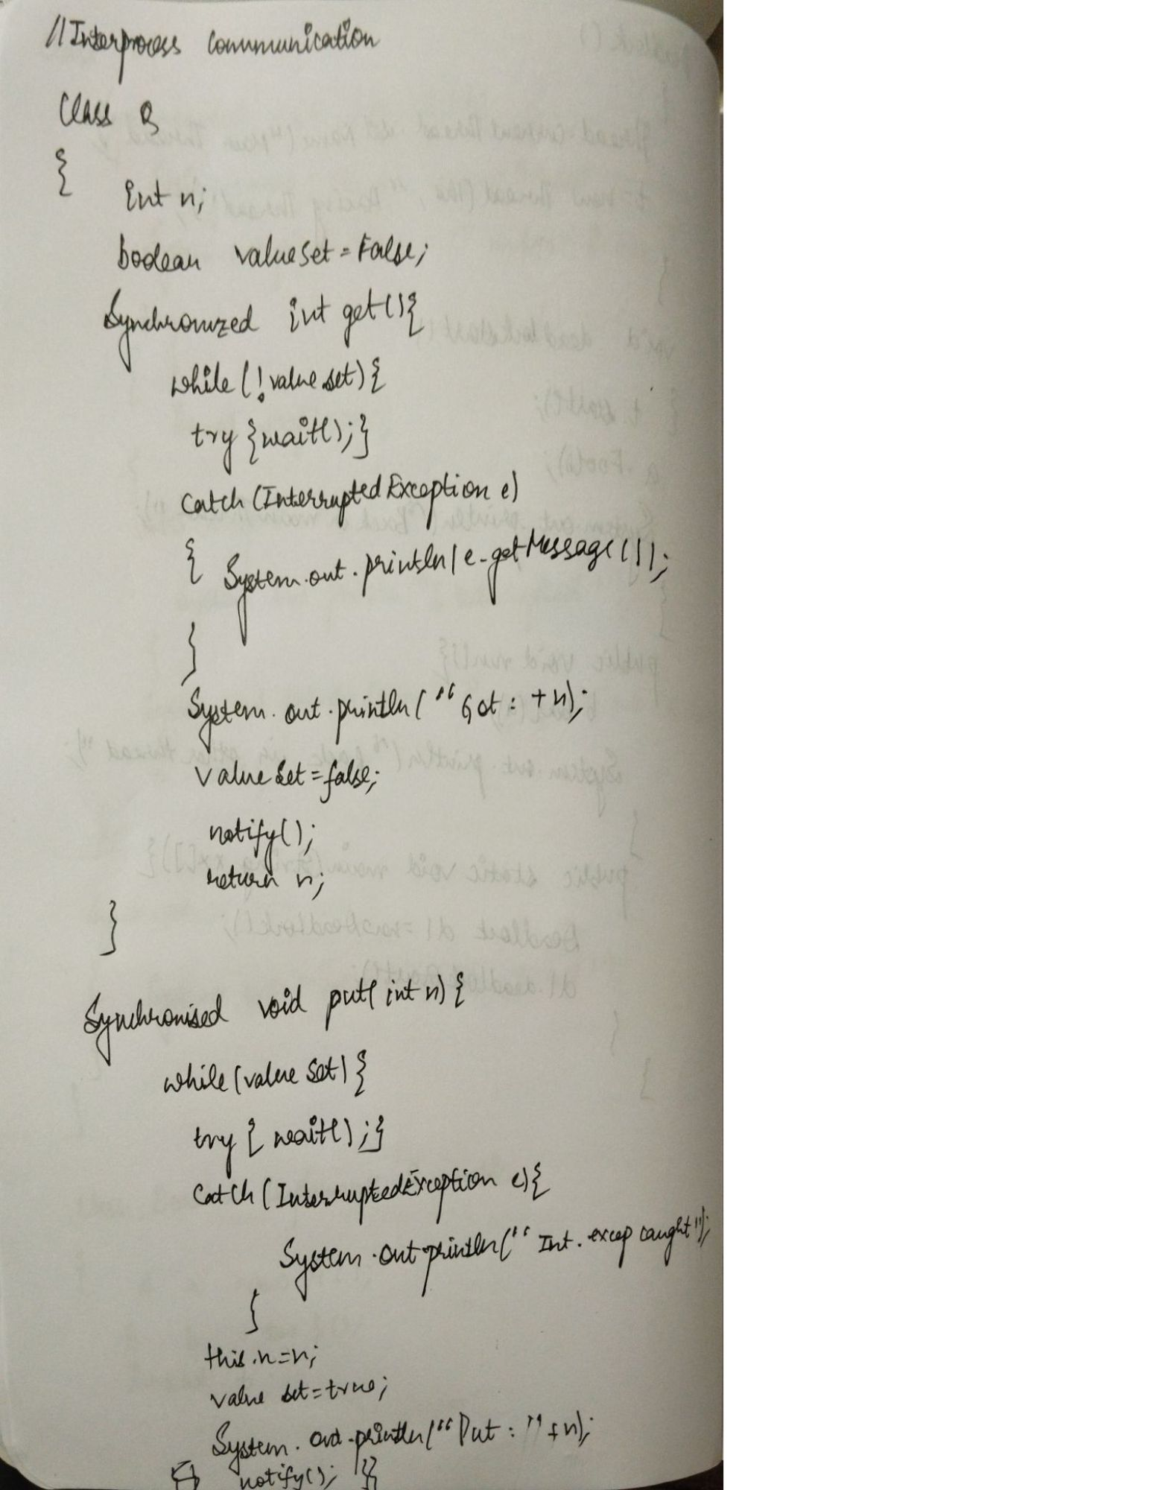

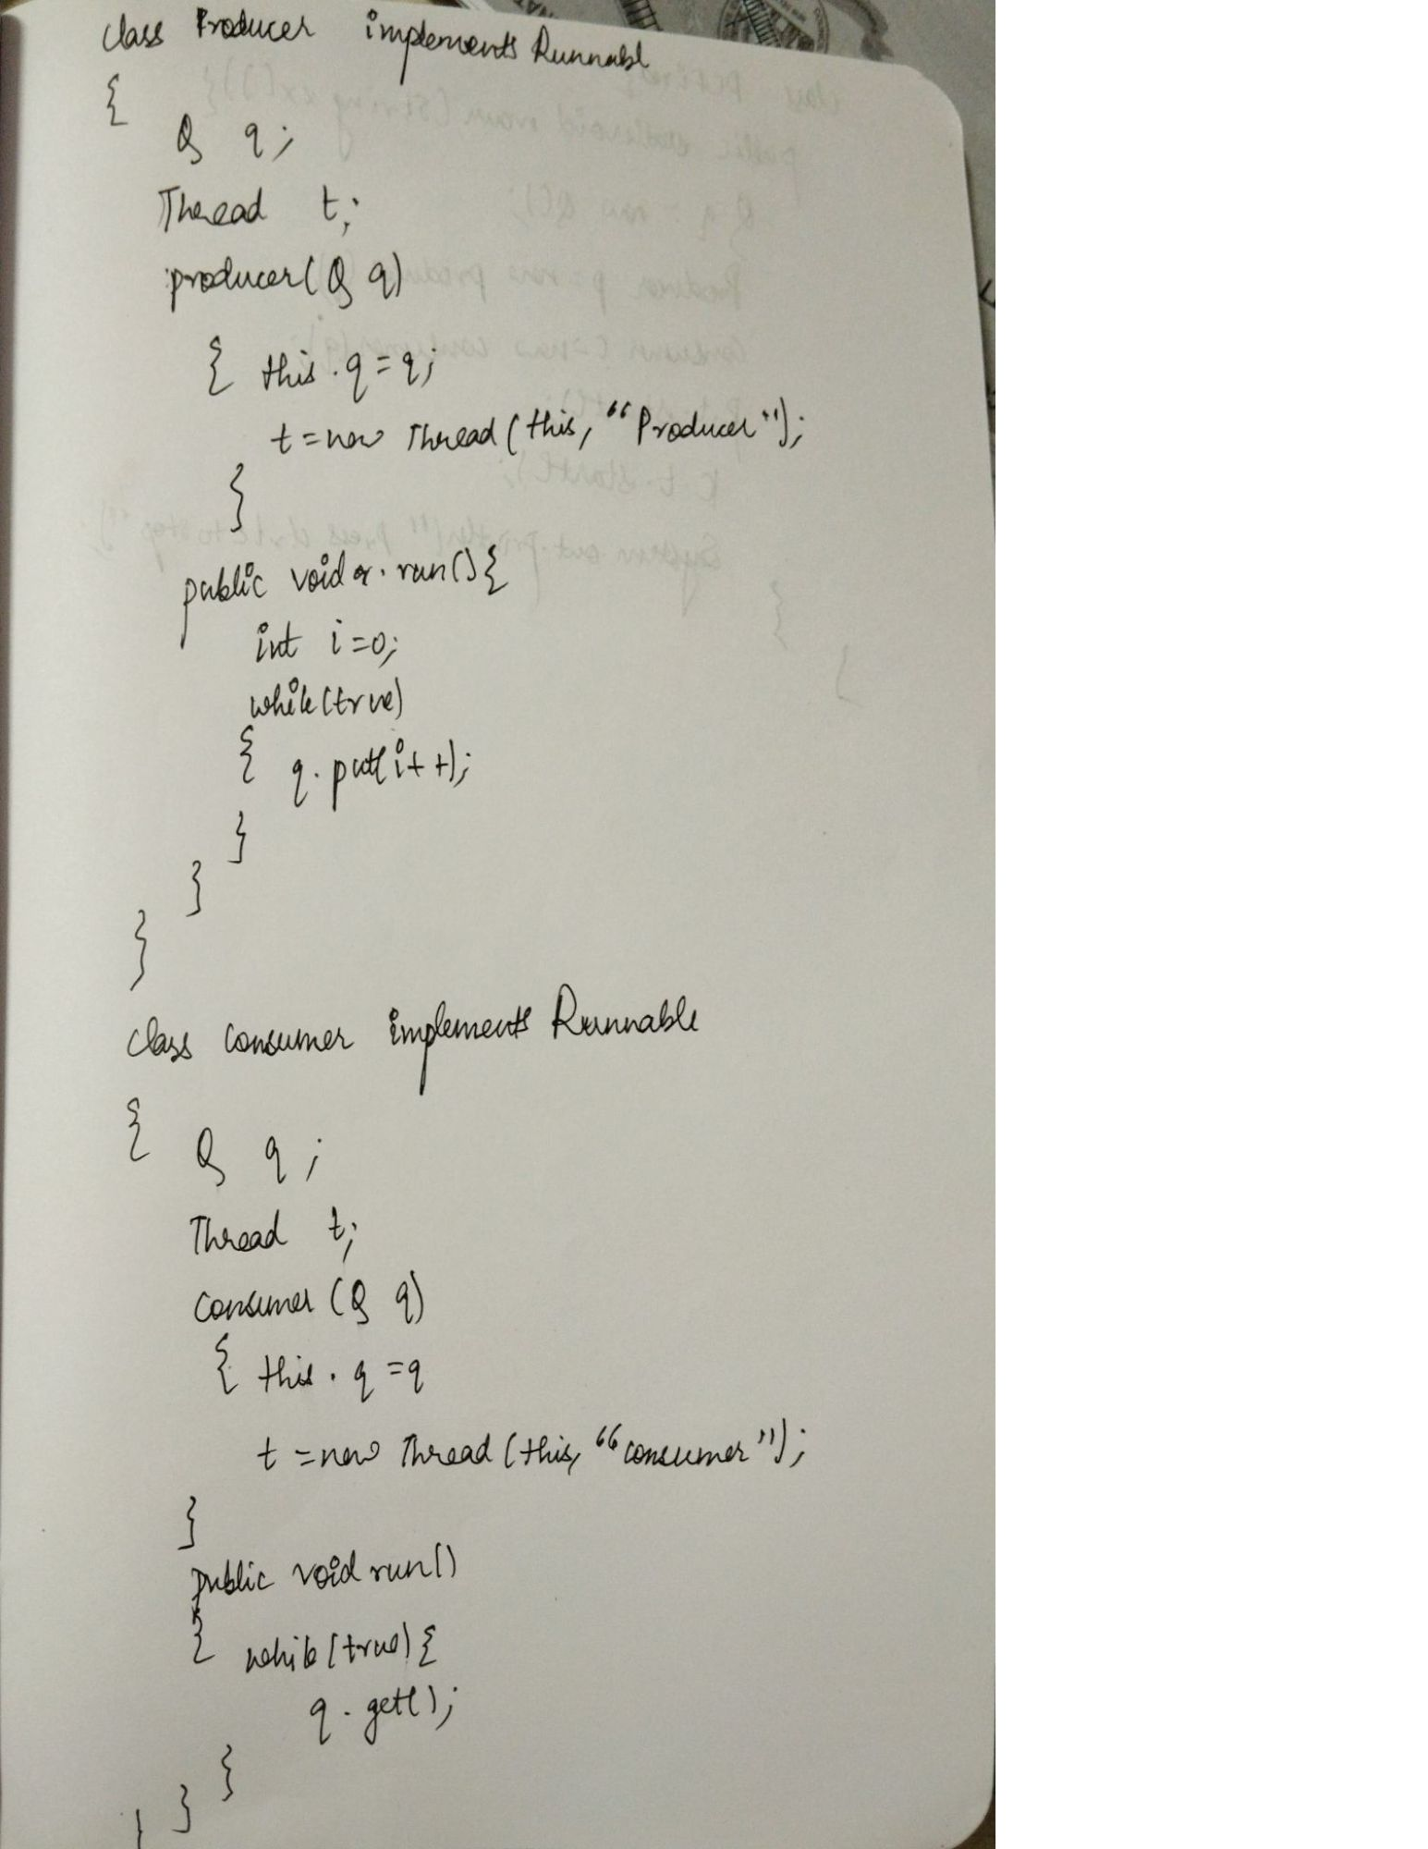

//Demonstrate deadlock

class A {

synchronized void foo(B b) {

String name = Thread.currentThread().getName();

System.out.println(name + " entered A.foo");

try {

Thread.sleep(1000);

} catch (Exception e) {

System.out.println("A Interrupted");

}

System.out.println(name + " trying to call B.last()");

b.last();

}

synchronized void last() {

System.out.println("Inside A.last");

}

}

class B {

synchronized void bar(A a) {

String name = Thread.currentThread().getName();

System.out.println(name + " entered B.bar");

try {

Thread.sleep(1000);

} catch (Exception e) {

System.out.println("B Interrupted");

}

System.out.println(name + " trying to call A.last()");

a.last();

}

synchronized void last() {

System.out.println("Inside B.last");

}

}

class Deadlock implements Runnable {

A a = new A();

B b = new B();

Thread t;

Deadlock() {

Thread.currentThread().setName("MainThread");

t = new Thread(this, "RacingThread");

}

void deadlockStart() {

t.start();

a.foo(b); // get lock on a in this thread

System.out.println("Back in main thread");

}

public void run() {

b.bar(a); // get lock on b in other thread

System.out.println("Back in other thread");

}

public static void main(String args[]) {

Deadlock dl = new Deadlock();

dl.deadlockStart();

}

}

